

**JOSÉ RIZAL UNIVERSITY**

**College Division**

**MARGIN TOP, RIGHT, BOTTOM 1”**

**LEFT 1.5”**

**PAPER 8.5 X 11**

**HeroesConnect: A Unified Web Application for Student Organizations at Jose Rizal University**

**A Project Study Proposal**

**Presented to the Faculty of the**

**College of Computer Studies and Engineering**

In Partial Fulfillment of the Requirements

for the Degree of Bachelor of Science in Information Technology

by

**Krissandro S. Alfaro**

**Ana Kristina O. Catacutan**

**Raniel Shean P. Santos**

2nd Semester, SY 2024-2025

*Hide Page Number*



**JOSÉ RIZAL UNIVERSITY**

**College Division**

**APPROVAL SHEET**

The thesis, entitled: **HEROESCONNECT: A UNIFIED WEB APPLICATION FOR STUDENT ORGANIZATIONS AT JOSE RIZAL UNIVERSITY** prepared and submitted by **Krissandro S. Alfaro, Ana Kristina O. Catacutan, and Raniel Shean P. Santos**, in partial fulfillment of the requirements for the degree of **Bachelor of Science in Information Technology** has been examined and recommended for acceptance and approval for Oral Presentation.

**_______________________**

**EMERSON C. FLORES, DIT**

Research Adviser

Approved by the PANEL OF EXAMINERS on Oral Defense on November 22, 2024 with a grade of _________.

**___________________**

**RONEL J. BILOG, DIT**

Chair

**_________________________ _____________________**

**DON ERICK J. BONUS, MSCS** **ISRAEL V. CARIÑO, MIT**

Member Member

**_____________________________________**

**SHARMAINE JUSTYNE R. MAGLAPUZ, DIT**

*Department Chair, Information Technology*

Accepted and approved in partial fulfillment of the requirements for the degree of **Bachelor of Science in Information Technology.**

**__________________________**

**LIZA R. REYES, MENGG-CPE**

Dean, Computer Studies and Engineering

*Hide page number*



**JOSÉ RIZAL UNIVERSITY**

**College Division**

**CERTIFICATE OF ORIGINALITY**

We hereby declare that the thesis entitled, **HEROESCONNECT: A UNIFIED WEB APPLICATION FOR STUDENT ORGANIZATIONS AT JOSE RIZAL UNIVERSITY** is our own original work carried out as Bachelor’s student at Jose Rizal University except to the extent that assistance from others in the thesis’ design and conception or in style, presentation and linguistic expression are duly acknowledged.

All sources used for the thesis have been fully and properly cited. It contains no material which to a substantial extent has been accepted for the award of any other degree at JRU or any other educational institution, except where due acknowledgement is made in the thesis.

**Krissandro S. Alfaro Ana Kristina O. Catacutan**



**Raniel Shean P. Santos**

May 18, 2024

*Hide page*

**ABSTRACT**

**Title : HEROESCONNECT: A UNIFIED WEB APPLICATION FOR STUDENT ORGANIZATIONS AT JOSE RIZAL UNIVERSITY**

**No. of Pages :**  105

**Researchers : Krissandro S. Alfaro**

**Ana Kristina O. Catacutan**

**Raniel Shean P. Santos**

**Adviser : Emerson C. Flores, DIT**

**School :** Jose Rizal University

**School Year :** 2024-2025

**Degree :** Bachelor of Science in Information Technology

INCLUDE A BRIEF ABSTRACT (Maximum of 200 words)

Heroes Connect is a web platform that uses cloud storage created to transform Jose Rizal University’s Student Development Office. The primary goal of this system is to provide a seamless platform that facilitates the submissions of proposals, encourages digital transparency, and stakeholder participation, and provides a strong file management system, financial tracking, and activity tracking features for academic and non-academic student organizations.

Our methodology, which combines Agile Software Development with the Scrum framework, places a strong emphasis on collaboration, adaptability, and iterative development to ensure continual improvement and alignment with HeroesConnects’s objectives. To provide insights, this research uses a mixed-methods strategy that combines qualitative and quantitative procedures. Qualitative data on user requirements and preferences is obtained through interviews with Student Development Office (SDO) staff, faculty advisers, and student leaders. Stakeholder satisfaction and preferences are measured through surveys, while user engagement patterns and feature usage are informed by HeroesConnect usage statistics. Our study intends to meet the various demands of academic and non-academic organizations at Jose Rizal University including SDO by optimizing the design and functioning of HeroesConnect and offering a comprehensive understanding of user requirements through the integration of these approaches.

The system underwent rigorous Alpha and Beta testing to evaluate its performance against ISO 25010 quality standards. During Alpha testing, HeroesConnect demonstrated strong usability (3.82) and functional suitability (3.67), with high scores across other metrics like reliability, security, and maintainability. Testers highlighted the system's intuitive interface and dependable core functionalities while suggesting minor compatibility enhancements.

Beta testing, supported by a presentation to organization officers, confirmed the system's improvements. Compatibility significantly increased to 3.71, and usability remained a strong point with a score of 3.67. Feedback from organization leaders emphasized the platform’s reliability and secure design while offering insights for further refinements.

The system’s features include real-time notifications, streamlined workflows, and interactive analytics dashboards. These capabilities have enhanced transparency, reduced delays, and empowered stakeholders with actionable insights. By securely storing and managing proposals and reports, HeroesConnect ensures data integrity and accessibility, aligning with institutional goals.

This study concludes that HeroesConnect effectively meets user needs, enhances event management processes, and promotes engagement within the organizational community. The system's robust foundation not only meets the current needs but also holds significant potential for broader application and ongoing improvement, opening up exciting possibilities for the future.

*Keywords: Heroes Connect, Student Development Office (SDO), Financial tracking, Jose Rizal University.*

TABLE OF CONTENTS

| *Title Page* | | *……………………………* | i |
| --- | --- | --- | --- |
| *Approval Sheet* | | *……………………………* | ii |
| *Certificate of Originality* | | *……………………………* | iii |
| *Abstract* | | *……………………………* | iv |
| *Table of Contents* | | *……………………………* | vi |
| Chapter 1 INTRODUCTION | | *……………………………* | 1 |
|  | Background of the Study | *……………………………* | 1 |
|  | Statement of the Objectives | *……………………………* | 7 |
|  | General Objectives | *……………………………* | 7 |
|  | Specific Objectives | *……………………………* | 7 |
|  | Conceptual Framework | *……………………………* | 8 |
|  | Significance of the Study | *……………………………* | 10 |
|  | Scope and Limitations | *……………………………* | 11 |
|  | Definition of Terms | *……………………………* | 12 |
|  |  |  |  |
| Chapter 2 REVIEW OF RELATED | |  |  |
| LITERATURE AND STUDIES | | *……………………………* | 15 |
|  | Related Literature and Studies | *……………………………* | 15 |
|  | Relevance of Related Literature and | |  |
|  | Studies to the Current Study | *……………………………* | 20 |
|  |  |  |  |
| Chapter 3 METHODOLOGY | | *……………………………* | 23 |
|  | Research Design | *……………………………* | 23 |
|  | Software Development Methodology | *……………………………* | 24 |
|  | Sources of Data | *……………………………* | 26 |
|  | Research Locale | *……………………………* | 27 |
|  | Method or Procedure | *……………………………* | 29 |
|  | Instrumentation and Data Collection | *……………………………* | 31 |
|  | Tools for Data Analysis | *……………………………* | 32 |
|  | |  |  |
| Chapter 4 PRESENTATION, ANALYSIS, AND INTERPRETATION OF DATA | | *……………………………* | 34 |
|  |  |  |  |
| Chapter 5 SUMMARY, CONCLUSIONS, AND RECOMMENDATIONS | | *……………………………* |  |
|  | Summary | *……………………………* | 59 |
|  | Conclusions | *……………………………* | 61 |
|  | Recommendations | *……………………………* | 62 |
|  | |  |  |
| **References** | | *……………………………* | 64 |
|  | |  |  |
| **Appendices** | |  |  |
|  | A. Letter of Request for Permission to Conduct Research | *……………………………* | 67 |
|  | B. Data Flow Diagram | *……………………………* | 69 |
|  | C. Flow Chart, ERD | *……………………………* | 72 |
|  | D. Documents, Memoranda, Data/Figures (if any) | *……………………………* | 77 |
|  | E. Sample Statistical Computations or Print-outs | *……………………………* | 89 |
|  | F. Grammarian Certificate | *……………………………* | 93 |
|  | G. Certificate of Turnover & Acceptance | *……………………………* | 94 |
|  | |  |  |
| **Acknowledgment** | | *……………………………* | 95 |
|  | |  |  |
| **Dedication** | | *……………………………* | 97 |
|  | |  |  |

**Chapter 1**

**INTRODUCTION**

This chapter presents a comprehensive overview of HeroesConnect: A Unified Web Application for Student Organizations at Jose Rizal University. The aspect of student organizations encouraging development and social participation is the starting point of the study. Following this, the chapter outlines the objectives of the study, the significance of the project for the university community, and the scope and limitations of the research. Every section is meant to give the reader a clear understanding of the basis of this study and its intended impact on the students and administration of the university.

**Background of the Study**

In today's educational landscape, student organizations are essential for fostering growth and community engagement. These organizations serve as platforms for collaboration, creativity, and social impact, enriching the university experience and contributing to a vibrant campus culture [1]. At Jose Rizal University, participating in an event and being a member of an organization is valued, it not only gives real-life experiences, but also builds a network, friendships, and memories for every student.

As we all know, in recent events, the world has started to adopt the digitalization of the company and Universities. It is also undeniable that the world is leaning towards changes in terms of technological approaches, such as work processes and procedures. Some people even claim that the element of competition in the future will be only with education [2].

The global economy has undergone unprecedented changes since the Industrial Revolution due to the rapidly expanding scientific knowledge and the swift advancement of information and communication technologies. The most significant component of the fourth industrial revolution is digitization, which makes it possible to connect people and technology. The digital economy is associated with the quick emergence and pervasiveness of information and communication technology across all spheres of human endeavor, necessitating fresh insights into the variables influencing economic growth and prosperity. We digitize data, information, and the systems and procedures that enable the business to run smoothly. We also digitally alter the business and its approach [3].

The term "digital economy" describes commercial endeavors enabled by digital technologies, mainly via the Internet. It includes digital payments, communication, advertising, and data analytics in addition to online commerce. The Internet of Things and cloud computing are important enablers that improve connectivity and streamline procedures. With platforms like Uber and Airbnb offering new business models, the sharing economy has developed. Cybersecurity, privacy issues, and making sure everyone has access to the internet are challenges. To expedite various administrative procedures and make it easier for citizens of member states and neighboring countries to access services, the European Union is investing in the fields of digital skills, digital infrastructures, digitalization of enterprises, and public services. This study offers a quantitative evaluation of the efficiency improvements that can be realized in the field of Erasmus+—the European Commission's program for youth, education, training, and sports—because of the ongoing digital transformation. The analysis covers the years 2021-2027. This program oversees a substantial fund earmarked for millions of students, instructors, and other staff members of higher education institutions in the EU and beyond to get instruction and training overseas [4].

During the requirements gathering, several challenges such as late submissions, formatting inconsistencies, budget tracking, and the need for efficient monitoring have been identified by the Student Development Office (SDO) of Jose Rizal University. These challenges may cause confusion and inefficiencies while processing the submitted documents, which results in mistakes or inadvertently holding up administrative work. Implementing standardized formatting guidelines enhances clarity and uniformity. The Digital Document Management System (DDMS) has many advantages. These are decreased use of paper, expedited access to public documents, avoided loss of documents, and made it easier for records to be transferred to archives [5].

When a facility or organization does an assessment, monitoring is necessary to ascertain how far along the process has come. This emphasizes how crucial monitoring is as a crucial step in the evaluation process. In addition, oversight is necessary to guarantee that all management and organizational objectives are met. When an institution or group does an evaluation, monitoring is necessary to ascertain how far along the process has progressed [6]. One of the most important duties of construction project management is monitoring and controlling project progress. The assessment that is now used to predict a construction project's effectiveness is still time-consuming, error-prone, and requires a lot of work [7].

Moreover, effective public financial management requires openness and transparency in the budget. Sufficient funding for digital transformation projects and educational initiatives is ensured by a well-managed budget, supporting both their successful implementation and long-term sustainability. A well-managed budget guarantees sufficient funding for digital transformation projects and educational programs, which supports their successful execution and long-term viability. Budget openness and transparency are key elements of the effective management of public finances, determining the fiscal risks, rational financial decision-making, increasing accountability by policymakers, and improving fiscal policies [8].

By incorporating these ideas, HeroesConnect serves as an example of how digital innovation, financial transparency, and efficient reward systems work together. One of the most important elements in employee motivation is said to be reward management. in carrying out their obligations at work. When workers complete their tasks effectively and in addition to pay, workers receive awards if they fulfill the requirements of their employers. The benefits are typically granted according to the job responsibilities [9]. Through recognition of the best student leaders, this program seeks to create a cooperative and stimulating community. HeroesConnect improves the whole educational experience by encouraging an atmosphere that acknowledges accomplishments, thereby making sure that every participant feels inspired and encouraged in their pursuits.

Descriptive analytics is essential to fully comprehending the functioning and influence of HeroesConnect's initiative, according to its point system, ranking, and data dashboard. We explore historical data on point accumulation, and participant involvement through the application of descriptive analytics methodologies. HeroesConnect recognizes the transformative power of analytics technologies and uses data-driven insights to improve its efforts and activities. Through the use of data dashboards with descriptive analytics features, the project can monitor important indicators, participant interactions, and program efficacy in real time. This gives stakeholders the ability to plan interventions, make well-informed decisions, and spearhead initiatives for ongoing improvement. The goal of current Learning Analytics dashboards (LADs) is similar to dashboards often used in industry. Their objective is to give students an overview of their course progress. Through the digital footprints that students create, graphic displays show patterns in the academic and engagement levels of the students and give them a foundation for awareness, reflection, and fresh ideas [10].

Additionally, the stakeholders can benefit greatly from the deployment of an email notification system. By putting such a system in place, the processes of documents can reduce overhead and improve productivity by significantly lowering or perhaps eliminating the expenses associated with disseminating information. The administration of the school can be assisted and facilitated by employing the information notification system [11].

The Heroes Connect project aims to improve digital infrastructure, making cloud storage privacy and data security essential. Given the increasing trend of data migration to cloud services, our framework for safe cloud storage provides an essential remedy. The majority of the extremely sensitive data kept on cloud servers includes internal business data and private medical records. Data is typically kept on a cloud server in the form of ciphertext to protect user privacy and data security. Data access control can be attained by encryption technology, which can be considered a security assurance [12].

The SDO aims to develop new ways of approving and renewing the proposals while our team will improve the current system by digitalizing the requirements and forms needed for the approval. The university is dedicated to updating administrative processes and creating a smooth experience for student organizations by strategically using technology through the Student Development Office (SDO).

The team hopes to lead the way in educational progress by utilizing "HeroesConnect," using technology to improve student participation, expedite administrative procedures, and create a vibrant campus community. A document application called an e-document has been created to address issues with document management, including inefficiencies in manual processing. This solution guarantees ordered storage and expedited document retrieval. The application is anticipated to increase work unit efficiency through black box testing by enabling prompt document access and routine maintenance [13]. The need for large amounts of physical space and the higher operating expenses related to preserving and protecting tangible documents are two of these difficulties. Additionally, the inability to access papers hinders both administrative procedures and instructional operations in the institution [14].

Furthermore, this project “HeroesConnect” will be a technological advancement within Jose Rizal University and be used to bridge the gap between the students, advisers, and administrators. By digitizing the system, Jose Rizal University will be part of the current educational innovation. These institutions, despite their importance, nevertheless rely on antiquated techniques like tangible files and folders, which presents several difficulties.

**Statement of the Objectives**

**General Objective**

The study’s main aim is to make a unified web application, HeroesConnect. This web application will streamline event proposal submission processes, enhance transparency through digital platforms, encourage collaboration among different stakeholders, and at the same time make available data analytics and tracking facilities for organizational activities.

**Specific Objectives**

1. Develop a streamlined system for event proposal and document submission, approval workflow, tracking, and organization evaluation, integrated with real-time email and system alerts.
2. Develop interactive data visualizations, analytics dashboards, and custom reports using descriptive analytics to enhance decision-making.
3. Set up a secure cloud storage space, which would be used in keeping and reading proposals, reports, and other relevant documents to guarantee the safety and validity of data.
4. Assess the system's effectiveness by measuring ease of use, approval workflow efficiency, notification response times, user engagement, data management satisfaction, and cloud infrastructure reliability through user surveys, system logs, and performance metrics.

By aligning the team’s objectives with the determined requirements and needs of HeroesConnect for Student Organization management, they can create an effective web application that will aid in enhancing and refining the overall management process.

**Conceptual Framework**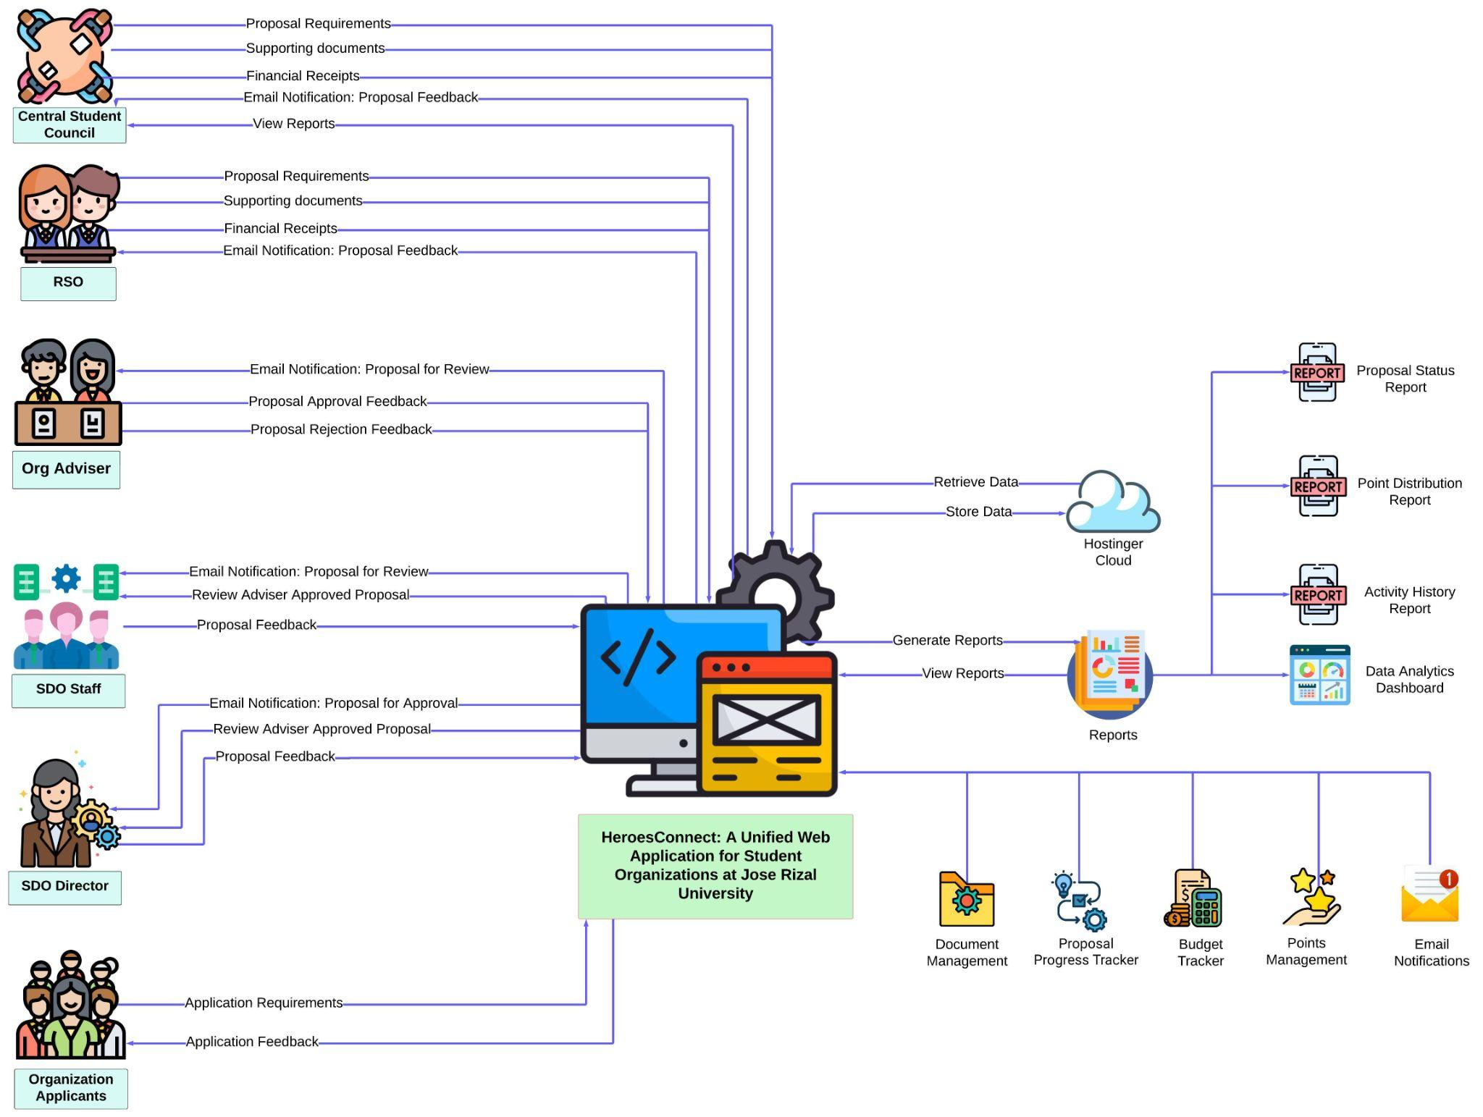

Figure 1.1: HeroesConnect Conceptual Framework

The conceptual framework (Figure 1.1) of the HeroesConnect Web Application facilitates communication and decision-making between users and administrative entities, thereby streamlining the proposal and evaluation processes for student organizations. Integrated with email and system notifications, the Organizational Adviser will review proposals and provide feedback. Approved proposals will be sent to the Student Development Office, the Student Coordinator will receive a notification and will initially review the Adviser Approved Proposal. Once checked and confirmed by the Student Coordinator, the SDO Director will be notified for final proposal review and approval.

The Central Student Council (CSC) will be able to view and monitor the proposals, and semi-annual, and annual reports submitted by the organizations. Additionally, the CSC can also create and submit proposals that will be subject to approval, further enhancing their role in organizational management.

The primary system for handling approval workflows, data management, proposal status, budget tracking, RSO Renewal, New Applications for Student Organizations, and organization evaluation is the HeroesConnect application. Additionally, it enables information queries to a database, processes data for backend functions, and generates reports for distribution to appropriate personnel. This structure guarantees effective handling of suggestions and feedback, improving the organization's general workflow and teamwork.

**Significance of the Study**

Administrators. This tool improves administrative efficiency through automation, intelligent reporting, and data analytics, which benefits administrators such as the SDO, department chair, dean, and the organization adviser. HeroesConnect makes it possible to make well-informed decisions and effectively support student organizations.

Student Council. HeroesConnect may suit the Student Council to facilitate the monitoring of all the proposals that have been made by RSOs. The organization management process becomes simplified through streamlining proposal submission, financial tracking, and progress monitoring.

Student Organizations. HeroesConnect streamlines organization management, simplifying processes including proposal submission, and financial and progress tracking. It may enhance organizational responsibility and transparency which results in more significant and successful projects.

Student leaders. HeroesConnect is a vital tool for student leaders because it may facilitate effective organizational management, transparency, and leadership development. This may include the current and future members of the organizations.

Developers. This project may serve as an important learning resource, providing developers with new knowledge and skills to apply in their future projects. It may also be a good experience for the developers to learn how to address common pain points and may propose different solutions to technical problems and this knowledge is precious.

Future Researchers. This research may help future researchers to identify the areas where further research is needed and identify where the existing knowledge is currently lacking. Future researchers may also gain new insights from this study, deepen their understanding, and provide a new direction for other research.

**Scope and Limitations of the Study**

The scope of HeroesConnect falls within the development and implementation of a comprehensive web application targeting streamline processes in the Student Development Office (SDO) of Jose Rizal University. This project is limited in its focus on optimizing the procedures related to all student organization, governance, event proposal, resource allocation, and communication within Jose Rizal University. The basic needed functionalities are proposal approval, member registration, registration for organization, event planning, scheduling, budget tracking, points, and document management.

Our project aims to develop a web application to enhance and improve the Student Development Office’s operations. A few of the system's limitations are the finance part, such as OVP Approval, Treasury, and signatories for other supporting documents attached. This project may not address other needs and problems of different organizations or administrators at Jose Rizal University.

**Definition of Terms**

Academic Organization: It refers to the context to Academic Organization student-led group or association that focuses on academic interests, disciplines, or fields of study. Academic Organizations seek to complement and enhance the official academic program.

Application: Refers to the based study an “Application” is a digital tool or platform designed to make certain tasks, procedures, or features easier to do. Examples of these include managing student organizations, organizing events, submitting proposals, and facilitating communication within the campus community.

Budget Clearance: This refers to the phrase “Budget Clearance” in the study that refers to the official approval procedure needed to allocate and distribute funds in support of the projects, events, and activities that Registered Student Organizations (RSOs) have proposed. Proposed budgets must be reviewed, verified, and authorized as part of this process to make sure they comply with institutional policies, funding caps, and standards for financial sustainability.

Checklist: Refers to the context of HeroesConnect a “Checklist” that is an organized list of duties, conditions, or actions that must be fulfilled or considered for particular procedures, such as submitting proposals, organizing events, or renewing organizational memberships. The checklist acts as a methodical instrument to guarantee correctness, completeness, and adherence to set rules and regulations.

Non-Academic Organization: Refers to the research, the term Non-Academic Organization means an association that concentrates on extracurricular activities, interests, and projects outside the official academic curriculum.

Proposal: In this study, a “Proposal” refers to a written request or document that student organizations make to plan, carry out, or finance events, projects, or activities. This paper describes the goals, specifics, needed resources, and anticipated results of the suggested program. The proposal is an essential instrument for decision-making, communication, and approval procedures inside the university's governance framework.

Registered Student Organization (RSO): In the study, the term refers to a formally recognized organization that has completed the required registration and approval process with the university.

Renewal: In context, refers to the research defined “Renewal” as the procedure that Registered Student Organizations (RSOs) use to amend, confirm, or prolong their official status, memberships, and privileges inside the university. To maintain compliance with institutional norms and procedures, this process may involve the submission of updated documents, membership lists, activity plans, or other pertinent information.

Requirements: These refer to the word “Requirements" in our study that defined as conditions, or criteria that must be reached to carry out a variety of tasks, functions, or activities about the management of student organizations, organizing events, submitting proposals, and university governance. The HeroesConnect application's features, modules, and

Workflows are designed, developed, implemented, and evaluated using these requirements as a reference or benchmark.

Student Development Office (SDO): Refers to within the context of the study Student Development Office (SDO) that is an administrative division tasked with fostering student development, engagement, and achievement. Acting as the focal point for student activities, collaboration, governance, and leadership development, the SDO is essential to organizational management, student well-being, and leadership development.

**Chapter 2**

**REVIEW OF RELATED LITERATURE**

**Related Literature**

Based on the study "Design of Web-Based Management Information System for Student Organizations in Kendal Regency Using Next.js Framework" by Susanto et al [15], developing a web-based management information system designed for student organizations aims to improve the general effectiveness of student organizations at Kendal Regency and ease up their administrative procedures. The web-based management information system has features for managing memberships, coordinating and organizing events, handling finances, and facilitating member collaboration and communication. The report highlights how crucial it is for student organizations to update their administrative procedures to boost accountability, productivity, and involvement. Utilizing web-based technologies such as Next.js, the system provides a versatile and sturdy framework for overseeing several facets of student group operations.

The study by Susanto et al [15] highlights the potential use of technology in improving the organization's management and efficiency and provides a piece of insightful information about the development and deployment of web-based management systems for student organizations.

In this era of tremendous change, educational organizations, school systems, and/or schools are under change pressures. A school, which is generally accepted as an open system has a more fragile structure and is subject to inescapable internal and external change pressures. A thorough analysis conducted by Noguerra Jr. [16] on how to develop a user-centric application for school organizations can be found in the paper "Designing a User-Centric School Organizational Club Application: System Development and Evaluation". The study provides useful information that we can use to enhance our proposal for HeroesConnect: A Centralized Web Application for Jose Rizal University Student Organizations. The study emphasizes the value of a user-centric design methodology, which is consistent with our objective of developing a platform that gives student organizations user experience and user-friendly interface design a top priority. Furthermore, the study's emphasis on aspects unique to school-based organizational clubs, like member communication and event planning, aligns with what we want to include in HeroesConnect.

In today's technological contexts, content delivery is a quickly changing field that requires efficient management techniques. The paper "Content Management Systems in Modern Technology Environments" by P. Mangesh et al [17] focuses on the difficulties that arise when publishing content across many user and application platforms in multiple channels and formats. According to the study, the following key aspects of content management are consistency and efficacy in content delivery, mapping, and managing content across various platforms and formats must be done effectively. With major benefits like extensibility, modularization, content and presentation independence, simple content management and publication, multi-language support, and user access

control management, and content management systems (CMS), especially enterprise content management systems (ECMS), are necessary tools for managing structured and unstructured content within the concerned offices and organizations. This study is relevant to our HeroesConnect concept since it highlights how important effective content management is to provide a flawless user experience. HeroesConnect seeks to ensure consistent and excellent content distribution across a range of user and application platforms by utilizing CMS concepts and technology. The focus of the study on user access control, modularization, and extensibility is exactly in line with our objectives of developing a user-friendly and adaptable online application for Jose Rizal University student organizations and administration.

A study by Soesanto et al [18] explores the vital role of information systems in enhancing student organization functions within university settings. The study uses the waterfall technique of system design to develop an application that is customized to fit the unique requirements of student groups. The authors define eight critical characteristics of online quality through rigorous focus group talks using the Delphi approach. These dimensions drive the design of the application to ensure maximum functionality and user experience. Their research offers useful information for creating technological solutions that enable student organizations to prosper in the digital age. They draw attention to the urgent need for student organizations to have more efficient reporting and assessment systems. Their study emphasizes the potential of technological solutions to solve resource constraints and improve operational efficiency in administering student organizations within institutions by adopting collaborative approaches and exploiting shared resources.

A study conducted by Moreno, F., & Sulasula, J. [19] investigated the feasibility and benefits of establishing a regional system of state universities and colleges (SUCs) in the Zamboanga Peninsula. The research analyzes enrollment data, budget allocations, and academic performance indicators, revealing significant advantages to implementing such a system. It emphasizes collaborative approaches among SUCs to enhance operational efficiency, academic quality, and access to higher education, ultimately fostering regional economic development and innovation.

In addition, a study from Iksan, M. Z., & Abdussalaam, F. A. [20] addresses the inefficiencies in personnel administration management at Politeknik Piksi Ganesha. The existing conventional procedures are considered inadequate due to their high susceptibility to infections and data loss. The writers used the Prototyping Method and Unified Modeling Language (UML) system modeling to build a solution while utilizing a qualitative research method and descriptive approach. The study's product, a web-based Personnel Administration Management Information System (SIMPEG), was created using the PHP programming language in conjunction with the Laravel framework and MYSQL database. This system provides mobile accessibility for staff members by streamlining employee data administration, centralizing employee files, and integrating attendance with device validation within the campus's public IP network.

In a further study by Asrin and Utami [21], the focus remained on the implementation of web-based school information systems in public elementary schools, particularly employing the waterfall model. The school has difficulty disseminating important information, such as student registration, events, and updates, because it now

relies on group conversations. The study suggests a website-based method to address this issue and provide parents and other interested parties with important educational information. It uses entity relationship diagrams, data flow diagrams, and context diagrams to build the system while utilizing the waterfall approach. System dependability is ensured by thorough black box testing. It is anticipated that the adoption will greatly enhance the school community's access to information and promote improved communication.

To facilitate analysis and report generation as per specific requirements, there arises a necessity to efficiently store event data within a database. This approval system serves to aid users in archiving and retrieving data in digital document format. It is legally required, but more importantly, it is socially responsible for public and private institutions to preserve their digital legacy. This goes double for both physical and digital records [22].

Both their internal and external contexts put ongoing pressure on organizations, including schools. Changes in social and demographic trends, new job patterns, technological advancements, and globalization are some of the factors driving schools to implement change interventions. Encouraging schools to grow and adapt is crucial to their continued existence as an institution and to bringing about positive social change in the community [23].

**Relevance of Related Literature to the Current Study**

**Table 2.1 Related Literature to the Current Study**

| **Title** | **Author** | **Date** | **Key Findings** | **Key Gaps** | **Present Study** |
| --- | --- | --- | --- | --- | --- |
| Design of Web-Based Management Information System for Student Organizations in Kendal Regency Using Next.js Framework | F. G. P. Susanto, N. I. Y. Fadlan and P. Haryani | May 2023 | Boost the Kendal Regency student organizations' efficacy. | * Simplify administrative processes. * Membership administration * event planning * Financial management * Member cooperation | The design and implementation of a web-based management information system customized for student. |
| Designing a User-Centric School Organizational Club Application: System Development and Evaluation | C. P. Noguerra Jr. | May 2023 | Importance of using a user-centric design approach | * Member communication * Event Preparation | In line to improve the concept for HeroesConnect: A Centralized Web Application for Jose Rizal University Student groups, the study offers a comprehensive analysis of creating a user-centric application for school groups. |
| Design of Reporting, Evaluation, and Monitoring Application for Student Organization in University | R. P. Soesanto, A. F. Rizana, L. Andrawina | January 2019 | Highlights how important information systems are to improving how student organizations operate in academic environments. | * Unique application * Essential attributes * Effective reporting * Technology overcoming | Examines the critical role information systems play in improving the operations of student organizations. Knowledge for developing technical solutions that help student organizations thrive in the digital era. |
| Organizational Change in Schools | K. Beycioglu and Y. Kondakci | January 6, 2023, | Under pressure to adapt, educational institutions, school systems | * Schools, as open systems, * Organizational transitions | Highlights the vulnerability of the school structure and its sensitivity to both internal and external change forces.  organizational change pressures encountered by educational organizations, school systems, and schools. |
| Towards a Regional System of State Universities and Colleges in Zamboanga Peninsula, Philippines | F. Moreno, J. Sulasula | August 1, 2023, | Examines whether creating a regional network of State Universities and Colleges (SUCs) in the Zamboanga Peninsula is feasible and advantageous. | * Enrollment data * Financial allocations * Academic performance metrics * Collaborative strategies | Emphasizes cooperative strategies between SUCs to enhance access, academic quality, and operational efficiency, aiming to promote innovation and regional economic growth. |
| Design of a Web-Based Personnel Administration Management Information System at Politeknik Piksi Ganesha | M. Z. Iksan, F. Abdussalam | June 28, 2023, | Deals with Politeknik Piksi Ganesha's inadequacies in personnel administration management. | * Develops a solution utilizing Unified Modeling Language (UML) system modeling and Prototyping Method. | Gives employees mobile access, centralizes employee files, streamlines employee data administration. |
| Implementing Website-Based School Information Systems in Public Elementary Schools Using Waterfall Model | F. Asrin, G. V. Utami | May 5, 2023 | Uses web-based school information systems in public primary schools. | * Suggests the utilization of a website with access to essential educational resources. | Implementing web-based school information systems in public elementary schools. ease dissemination of information. |

**Chapter 3**

**METHODOLOGY**

## **Research Design**

The research design of HeroesConnect is a mixed-methods approach that combines both qualitative and quantitative methods to give a complete view of the users’ needs, preferences, and ways in which they interact. The qualitative data will be collected through open-ended interviews and questionnaires which allow for an in-depth exploration of users’ experiences as well as their perspectives. Moreover, studying patterns of use through quantitative analysis enables one to see how organizations behave over time. Therefore, it is important to consider scholarly articles, institutional reports, and industry figures to get an overall understanding of HeroesConnect’s applications. Through the use of flowcharting techniques, the step-by-step process of data collection will be shown; this will also involve Data Flow Diagrams (DFDs) that show the movement of information within the system and help identify critical data points and processes. This strategy ensures a detailed analysis of the study results thereby enabling decision-making on how best to implement HeroesConnect to achieve its desired objectives.

**Software Development Methodology**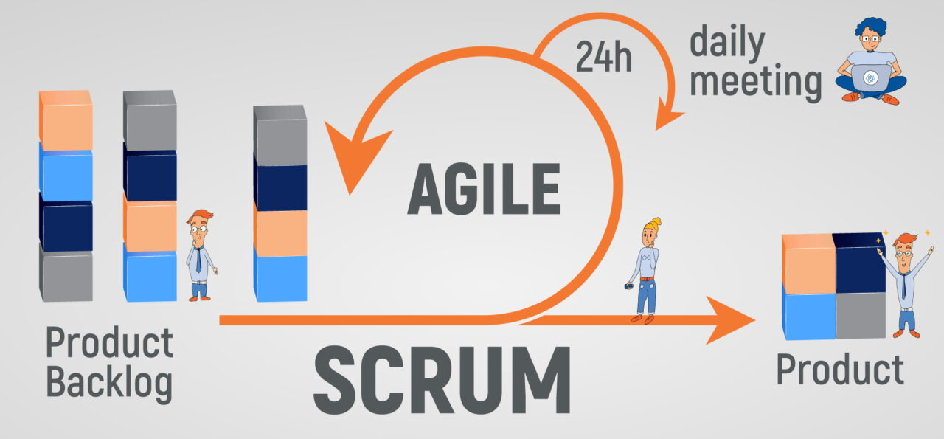

Figure 3.1: Agile software development with the Scrum framework [24]

﻿ When developing HeroesConnect, utilizing Agile Software Development with the Scrum framework it offers numerous benefits for the team and the project. With Scrum, it can adopt an iterative and collaborative approach that encourages transparency, adaptability, and continuous improvement. The close collaboration among team members and end users is a key advantage. Regular meetings such as sprint planning, daily scrums, and sprint reviews ensure that everyone is aligned on project objectives, priorities, and progress. This enhances communication and facilitates timely feedback and adjustments, leading to a product that closely meets consumer needs.

The team will use a defined process with set steps to ensure that project management and delivery are effective. This is what the team will typically do in each stage:

Initiation. This involves setting the project vision, objectives, and scope. Creating the project charter, identifying stakeholders, and setting initial requirements and goals for the project are some of the key activities involved in this phase.

Planning. While engaged in this phase the team shall break down the project into smaller components and create a detailed plan for each sprint. Activities like sprint planning meetings, where the team selects tasks from the product backlog, estimate effort, and sets sprint goals and timelines.

Execution (Sprints). This stage is where the actual work takes place. Every sprint usually lasts 1-2 weeks and contains tasks picked out during sprint planning. There will be daily meetings to review progress and confirm that team members meet their promises are held daily in Scrum.

Review and Retrospective. At the end of every sprint, the team will conduct a sprint review where they demonstrate to stakeholders the work that has been done and to get their input; this is followed up by the sprint retrospective as they look at what went right or wrong, as well as make changes needed for the next sprint.

Closure. Once all planned sprints are completed and the project objectives are met, the project is closed out. This stage encompasses finalizing documentation, holding a final review with stakeholders as well as handing over project deliverable things to various teams or even users.

Scrum's ability to adapt to changing priorities and needs is another important advantage. The team can make changes as the project moves forward in response to changing needs, market changes, and stakeholder feedback. These changes are essential to respond quickly and provide excellent value to our customers and end users in the ever-changing world of software development.

All things considered, using the Scrum framework enables the team to collaborate more effectively, create iterative value, and react faster to change, all of which contribute to the creation and implementation of HeroesConnect successfully.

## **Sources of Data**

Interviews with student leaders, faculty advisers, and staff from the Student Development Office (SDO) to understand user needs and requirements will be the source of Heroes Connect's primary data source. Again, conducting interviews with user groups and testing prototypes of system designs among student organizations are vital for successful project implementation. Moreover, surveys and questionnaires will be offered to stakeholders to gather information on satisfaction rates and preferences while usage data from the HeroesConnect application will clarify users' interaction patterns and the extent of use of features by users.

For secondary sources of data, the developers will consult the aforementioned literature presented, as well as any other related studies that may be gathered during the development of the HeroesConnect app.

## **Research Locale**



Figure 3.2:Jose Rizal University Building [25]

The study will be carried out at Jose Rizal University (JRU), a college located at 80 Shaw Blvd Mandaluyong City, Philippines, known for its very active student life and a wide array of student clubs.

JRU’s Registered Student Organizations (RSOs) encompass diverse types of academic, cultural, recreational, and advocacy-associated clubs. They are vital components within the institution’s ecosystem that offer learners avenues to explore their interests, work together with colleagues on common areas of interest as well as make significant contributions to campus life as well as society.

The research site at JRU with its changing array of student organizations on campus supported by SDO provides a unique laboratory for studying organizational management intricacies, communication dynamics, and technology integration within the student community. This environment provides essential insights and opportunities for developing and implementing the proposed web application, HeroesConnect, which aims to improve the experiences and effectiveness of JRU student organizations.

**Sample and Population**

JRU has a well-established Student Development Office (SDO) that serves as the main hub for coordinating and supporting 24 Academic (17) and Non-Academic (7) Registered Student Organizations (RSOs) activities, encompassing a current total of 472 members. This office facilitates communication, coordination, and resource allocation among registered student organizations to ensure smooth operations and an optimal condition for student involvement and leadership development.

In order to conduct the test on the HeroesConnect system, a sample will be taken from the entire population of RSOs. Each selected RSO will have one representative involved in the testing process.

| **Participants** | **Target Participants** |
| --- | --- |
| Academic RSOs | 9 RSOs (50% of 17) |
| Non-Academic RSOs | 4 RSOs (57% of 7) |
| RSO Advisers | *Advisers of the selected RSOs, acknowledging that multiple RSOs may share the same adviser.* |
| Department Chairs | *Department chairs of the selected RSOs, acknowledging that multiple RSOs may share the same chair.* |
| Student Coordinator | 1 |
| SDO Director | 1 |

Table 3.1: Target Participants

These participants are going to be engaged in testing of all stages and also to get detailed feedback to improve HeroesConnect before starting large-scale production. This approach is important because it guarantees comprehensible assessment and an increased number of suggestions for the system's enhancement.

## **Method or Procedure**

The research design for implementing HeroesConnect involves a mixed-methods approach, combining qualitative and quantitative methodologies to gather comprehensive data. This includes conducting interviews, and surveys, and analyzing usage data to understand user needs, preferences, and interaction patterns. Stakeholder engagement is crucial, with interviews planned with student leaders, faculty advisers, and staff from the Student Development Office (SDO). Surveys will be administered to stakeholders to gather satisfaction rates and preferences, while usage data from the HeroesConnect application will inform user interaction patterns and feature usage. Additionally, literature reviews, analysis of institutional data from Jose Rizal University (JRU), and industry reports will provide context for system requirements and technology viability. The main objective here is to look at JRU’s varied number of Registered Student Organizations (RSOs), using SDO as the main point of reference, and study organizational dynamics and technology integration among students.

When approval has been granted for the proposal research, the team will move to the planning and preparation stage. This entails creating project plans and timelines, developing interview and survey questions, and establishing data-gathering systems. The team will also ensure that participants give their consent and permission in order to do activities that are ethical.

After data collection, the system development and testing stage of the project will ensue. An initial version of HeroesConnect will be developed based on the requirements that are collected. During the usability testing, a set of Test Users will be utilized to provide feedback that will help in further enhancements of the system.

Once data collection is done, the project will progress to the next stage, which is data analysis. Qualitative data from interviews will be analyzed to find out general features and ideas, and quantitative data from surveys will be used to quantify satisfaction levels and direction. Results data for the HeroesConnect application shall be collected and evaluated to pinpoint interacting patterns and feature utilization, while findings derived from the literature review and institutional studies shall be compiled to provide a context of the system.

Lastly, the refinement stage of the system entails incorporating specific structural modifications and adjustments that will make the system more effective and responsive to the stakeholder needs. Further tests will be conducted to verify the efficiency and usability of the system. The process of evaluating and reporting will be conducted in the form of surveys and interviews, finalizing and compiling the system's impact into a comprehensive report, and preparation for the final defense presentation.

## **Instrumentation and Data Collection**

To effectively gather comprehensive data on user needs, preferences, and satisfaction levels, as well as insights into operational procedures of student organizations at JRU, researchers will develop tailored interview guides and survey questionnaires for stakeholders, including student leaders, faculty advisers, and staff from the Student Development Office (SDO), along with administrators.

Survey questionnaires will be designed to collect quantitative data on user preferences, satisfaction levels, and usage patterns of the HeroesConnect application, focusing on proposal submissions, budget management, pre and post-activity procedures, creation of new organizations, and submission requirements at JRU. Usage data from the HeroesConnect application will be collected through implemented tracking mechanisms and analyzed using analytics tools to identify trends and areas for improvement.

Interview guides are highly beneficial when it comes to instrumentation and data gathering. These guidelines ensure that every crucial subject matter and query is included in the interview process hence minimizing the chances of not covering essential information. The consistency of interviews enhances reliable and valid data collection.

Moreover, these guidelines allow for open and profound answers that make respondents feel comfortable on many occasions during interviews. In addition, due to this approach, the research takes less time and it allows for subsequent investigation related to the obtained information from participants making it orderly, holistic, and successful during data collection for the study.

## **Tools for Data Analysis**

As a method, flow diagrams, Data Flow Diagrams (DFDs), and Entity-Relationship Diagrams (ERDs) will be used to show steps in sequence, how data flows and database structures respectively thus ensuring an orderly and effective implementation process.

Flowcharts will visually map out data collection processes, specifying sequential steps for interviews, surveys, and usage data tracking, while also outlining the workflow for data analysis and interpretation. The team will use statistical methods like descriptive statistics and regression analysis to analyze quantitative data, and qualitative techniques like thematic analysis to interpret insights from interviews and open-ended survey responses.

Descriptive statistics will be utilized to describe and summarize the collected data. Statistics like mean, median, mode, standard deviation, variance, and frequency distributions will be computed to get a central tendency, dispersion, and shape of the data. This will include: Calculating the average towards the users' satisfaction score, Determining the distribution of the perceived ease of use of the HeroesConnect application, and Identifying the response categories' frequency to understand the majority's or the most common preference/concerns. Data collected in the present study will be subjected to regression analysis to test hypotheses such as usage frequency and perceived usefulness and their effects on general user satisfaction.

Combining findings from both quantitative and qualitative analyses will give us a complete understanding of user needs, preferences, and satisfaction levels. This information will guide the design and development of the HeroesConnect application to improve organizational management and efficiency at JRU.

**Chapter 4**

**PRESENTATION, ANALYSIS, AND INTERPRETATION OF DATA**

This chapter goes over the necessary techniques and steps, which consist of system development, documentation, and testing for the project. It draws attention to the key elements and technology employed in developing the system. The first section of the chapter outlines the basic specifications and objectives that directed the creation of the app, making sure that the finished result not only satisfies user wants but also tackles important industry difficulties. The development methodology used is then covered, emphasizing how agile and iterative processes enabled product refinement based on the requirements of SDO.

HeroesConnect sought to offer a centralized system that made it simple for students to submit documentation and suggestions for events. It had workflow automation tools that enabled real-time tracking, approval procedures, and feedback, guaranteeing that everything was done methodically.

**Develop a streamlined system for event proposal and document submission, approval workflow, tracking, and organization evaluation, integrated with real-time email and system alerts.**

The researchers developed features to handle the creation of event proposal, and submission. A module for tracking was implemented for a seamless approval workflow, a Point module for orgaization evaluation integrated will real time alerts.

Figure 4.1 shows the officer side (Organization President) of the Proposal Application Form, where organization officers like the Vice President or Secretary can create event proposals. The Organization's President, Vice President, and Secretary have access to view and edit their submitted proposal. The form structure is benchmarked from the Junior Philippine Computer Society – JRU Chapter (JPCS–JRU) activity proposal form. The form includes the type of activity, title of the activity, organizer, level, participants, date, time, venue, and objectives, along with the details of the budget request.

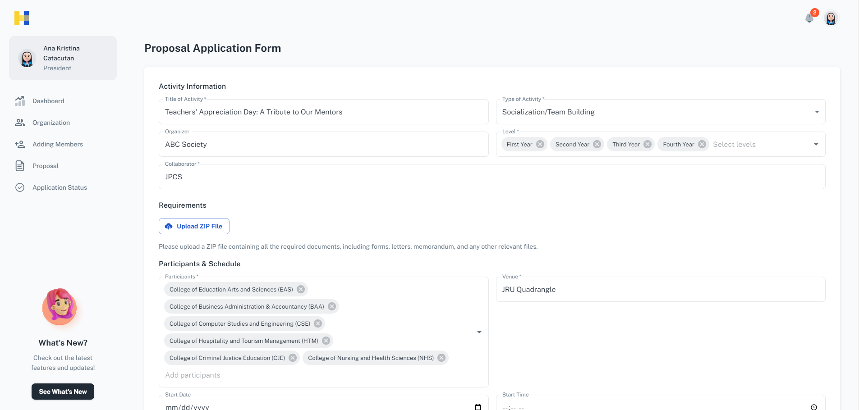

Figure 4.1: Proposal Creation

The title of the Activity field is the title of the proposed event, in this case, the event is Teachers' Appreciation Day: A Tribute to Our Mentors. The title field reflects the theme and purpose of the activity. The Organizer field is the group or the organization that is responsible for overseeing and implementing the event. The Collaborator field is the collaborating organization for the event, ensuring that multiple groups are involved in the planning process. The Type of Activity is a dropdown list, where the officer will select what type of event the proposal will fall into. For the Level field, the officer can select the level (First Year to Fourth Year students) of the target participants. The requirements section is where the officer can upload supporting documents for the proposal.

The team suggests uploading a "zip" file, for better organization and ease of handling. This will ensure that multiple documents are consolidated into one file. The Participants field ensures selection of multiple departments and as for the Schedule, the officer can select the Start Date and Start Time to provide a clear start time. End Date and End Time, allowing the approvers to assess the total duration of the event. The Venue field is the designated venue for the event, confirming where the event will take place.

Continuing on Figures 4.2 and 4.3 show the several important details necessary for the event's proposal approval process. By providing these detailed fields, approvers will be able to access the events event's scope, objectives, and financial requirements thoroughly. The officers can easily see and monitor their budget with the provided Budget Limit and Total Budget. The Requested By (President) and the Secretary identify the individuals responsible for the proposal, ensuring accountability for the proposal submission.

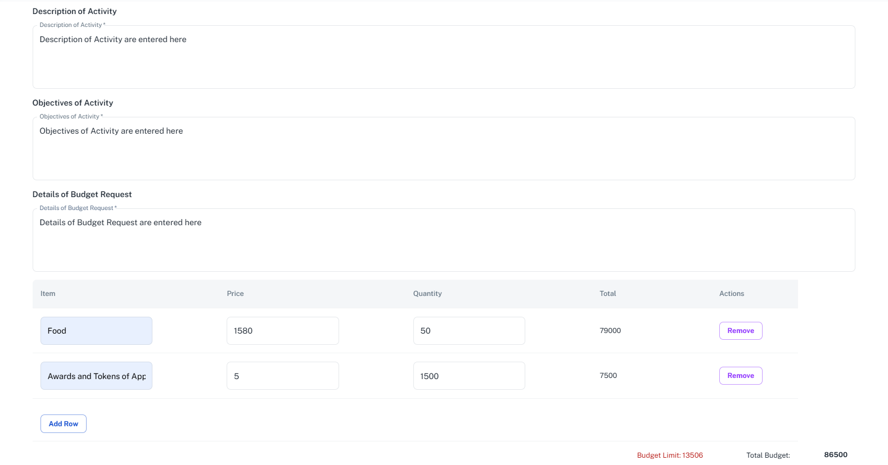

4.2: Proposal Form

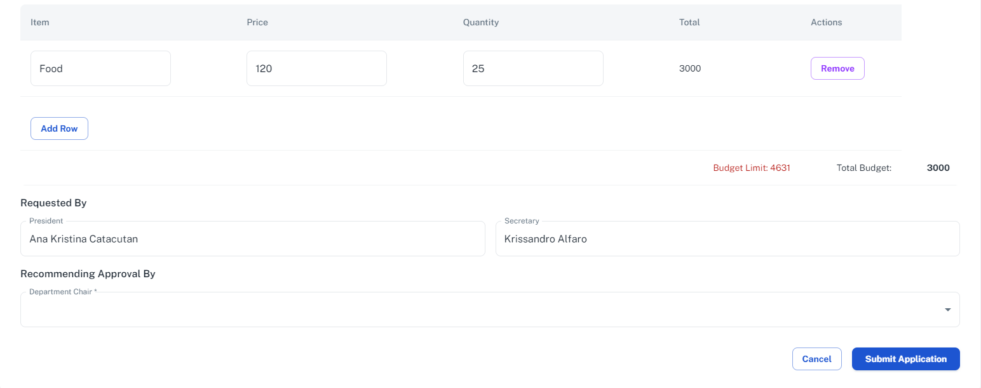

4.3: Proposal Form - Continuation of Fields

Figure 4.4 shows the approval flow of the proposal. Once the proposal has been submitted, the proposal must go through first the signing of the Organization Adviser. Next is the endorsement that will be performed by the Department Chair and Dean. The proposal will then be received and checked by the Student Coordinator if all necessary pre-activity requirements are submitted. Once confirmed it will be received by the SDO Director for the final approval.

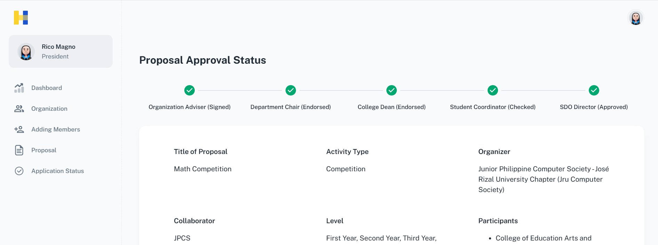

Figure 4.4: Proposal Approval Workflow

A tracker is necessary in a system especially if there is an approval workflow. The proposal tracker is implemented to help its designated users to track the status of the proposal. As shown in Figure 4.4 it is essential for maintaining transparency and ensuring efficiency through the approval process.

As shown in Figure 4.5 proposal tracker has five (5) stages for Academic Organizations, the Organization Adviser, Department Chair, College Dean, Student Coordinator, and SDO Director. Once the tracker has a checked mark. The proposal will go through a sequential checking and approval process, meaning that each personnel must review and approve it in a particular order. The idea must first be signed by the Organization Adviser. After signing, it goes to the Department Chair then the Dean, where it waits to be endorsed. The proposal will next be checked by the Student Coordinator. Lastly, the ultimate permission is granted by the SDO Director. To ensure a comprehensive and organized assessment, the proposal cannot proceed through the approval process until each step is finished in the right order.

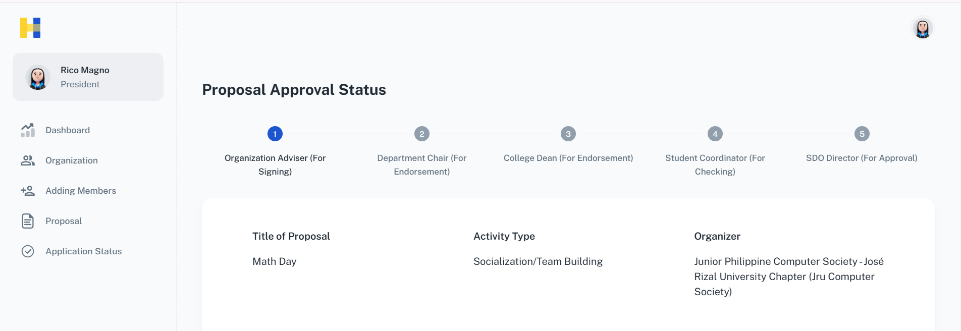

Figure 4.5: Proposal Tracker Stages (Academic)

For Non Academic Organizations, approvals will go through the Organization Adviser, Student Coordinator, SDO Director, as shown in Figure 4.6.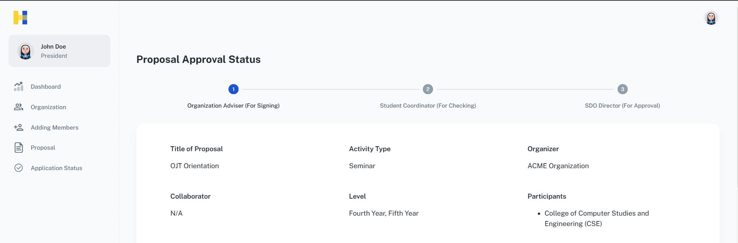

Figure 4.6: Proposal Tracker Stages (Non Academic)

Figure 4.7 shows how the personnel uses the application's approval form to assess and perform Approval, Rejection, or trigger the Revision on the proposals created. Every stage delineates the requisite measures that the approver must undertake to guarantee a seamless workflow in the processing of proposals.

After opening the application, the approver, for example, the Student Coordinator clicks on the “SDO Director” module from the sidebar menu. Then click on the Proposal Approver tab. The table includes a list of proposals that have either been approved or rejected, as well as those that are in progress. After looking through the list, the approver chooses a particular proposal to check and review. The Proposal’s complete details, including the event title, goals, date, budget, and supporting materials, are displayed when you click on it.

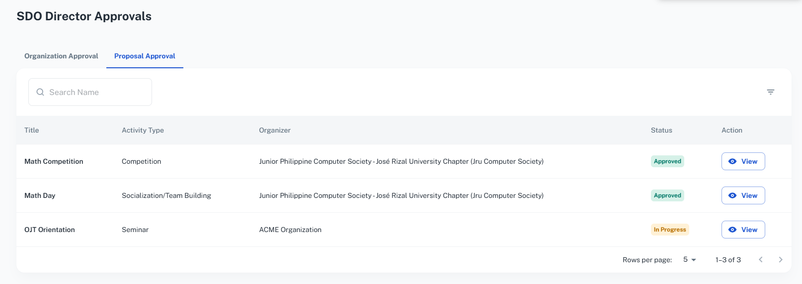

Figure 4.7: Proposal Data Table

In Figure 4.8 the feedback box, the approver may offer feedback or ask for more details if needed. The approver chooses from the following alternatives after reviewing the review, "Approve" if the plan satisfies all requirements and is prepared for execution, "Reject" if the plan is not in line with the requirements. The status of the proposal has been changed to either approved, rejected, or under revision. The applicant receives an email notification from the system automatically upon submission of the approval or rejection.

The system automatically updates the proposal tracker's status when the Approver clicks the "Approve" button on a proposal. The approval is reflected in this modification, which all pertinent parties can see. Since the organization officers can now see that their request has been formally authorized, the new status helps to ensure openness.

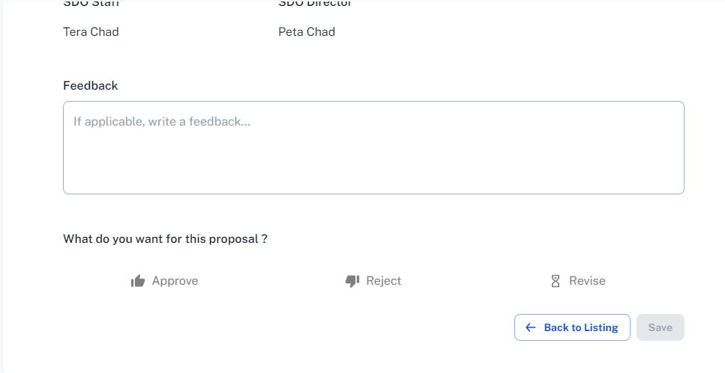Figure 4.8: Approval of Proposal

Figure 4.9 describes how the organization Student Coordinator and Director can use the Budget Tracker module to check the budget details. The procedure facilitates appropriate financial management within the application and guarantees transparency in the tracking of event budgets.

The Budget Tracker module is accessed by the user through the sidebar menu. The summary should load quickly and display precise financial information pertinent to the event proposal that was chosen. This prevents any confusion or misallocation of funds by guaranteeing that the budget is tracked under the appropriate organizational body.

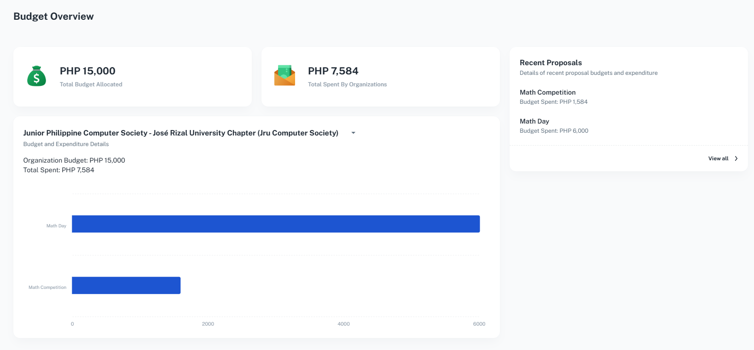

Figure 4.9: Budget Tracker

In Figure 4.10, the Administrator checks the list of organizations after navigating to the Organizations module. Click the Budget button in the top right corner of the screen after choosing the preferred organization. 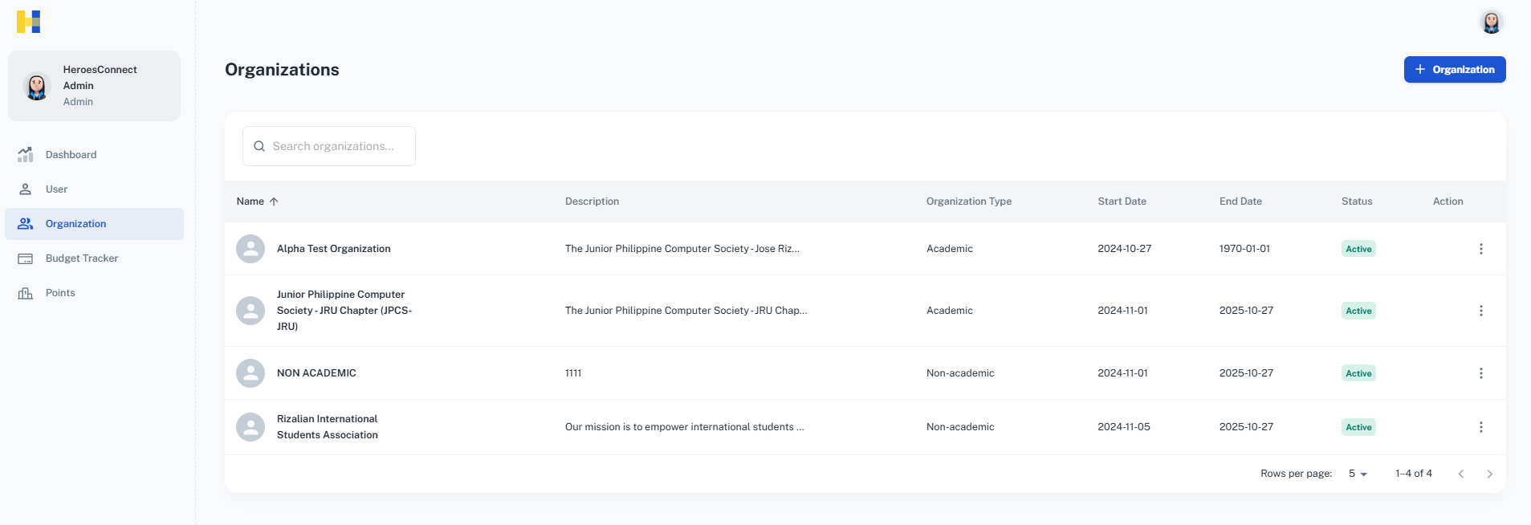

Figure 4.10: Organization List

Figure 4.11 shows the Admin clicks on the Update Budget button and sets the organization's budget limit by the accreditation level's budget cap. This procedure guarantees that the organization's budget is in line with the precise constraints imposed by its accreditation status and number of enrollees.

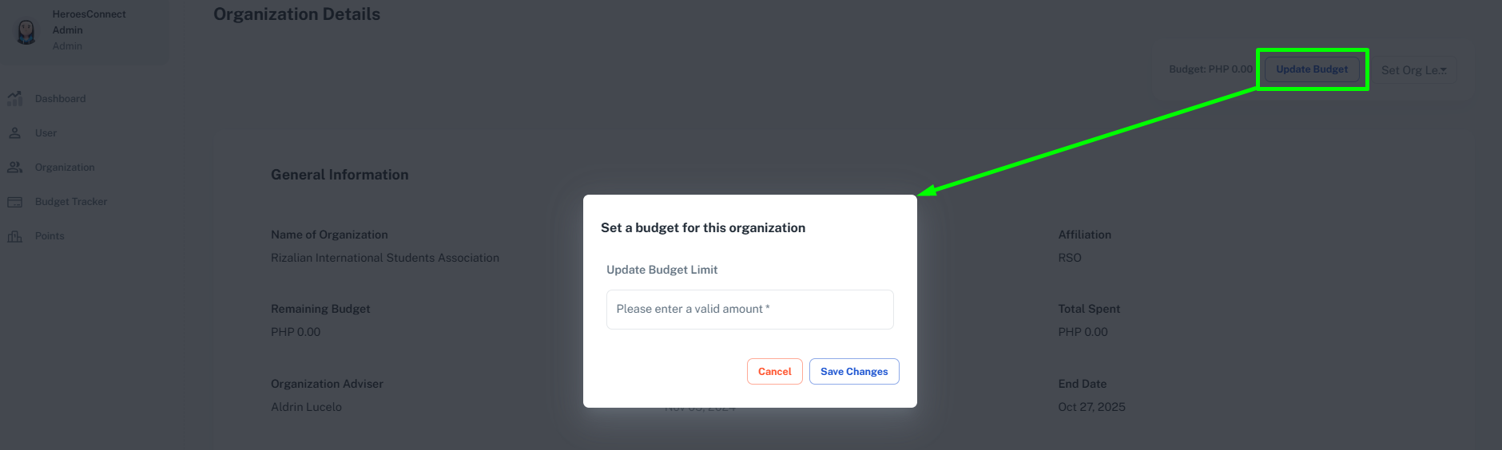

Figure 4.11: Updating of Budget

Figure 4.12 shows the Admin clicks on the Org Level dropdown, this sets the organization's level by the level's budget cap and number of enrollees.

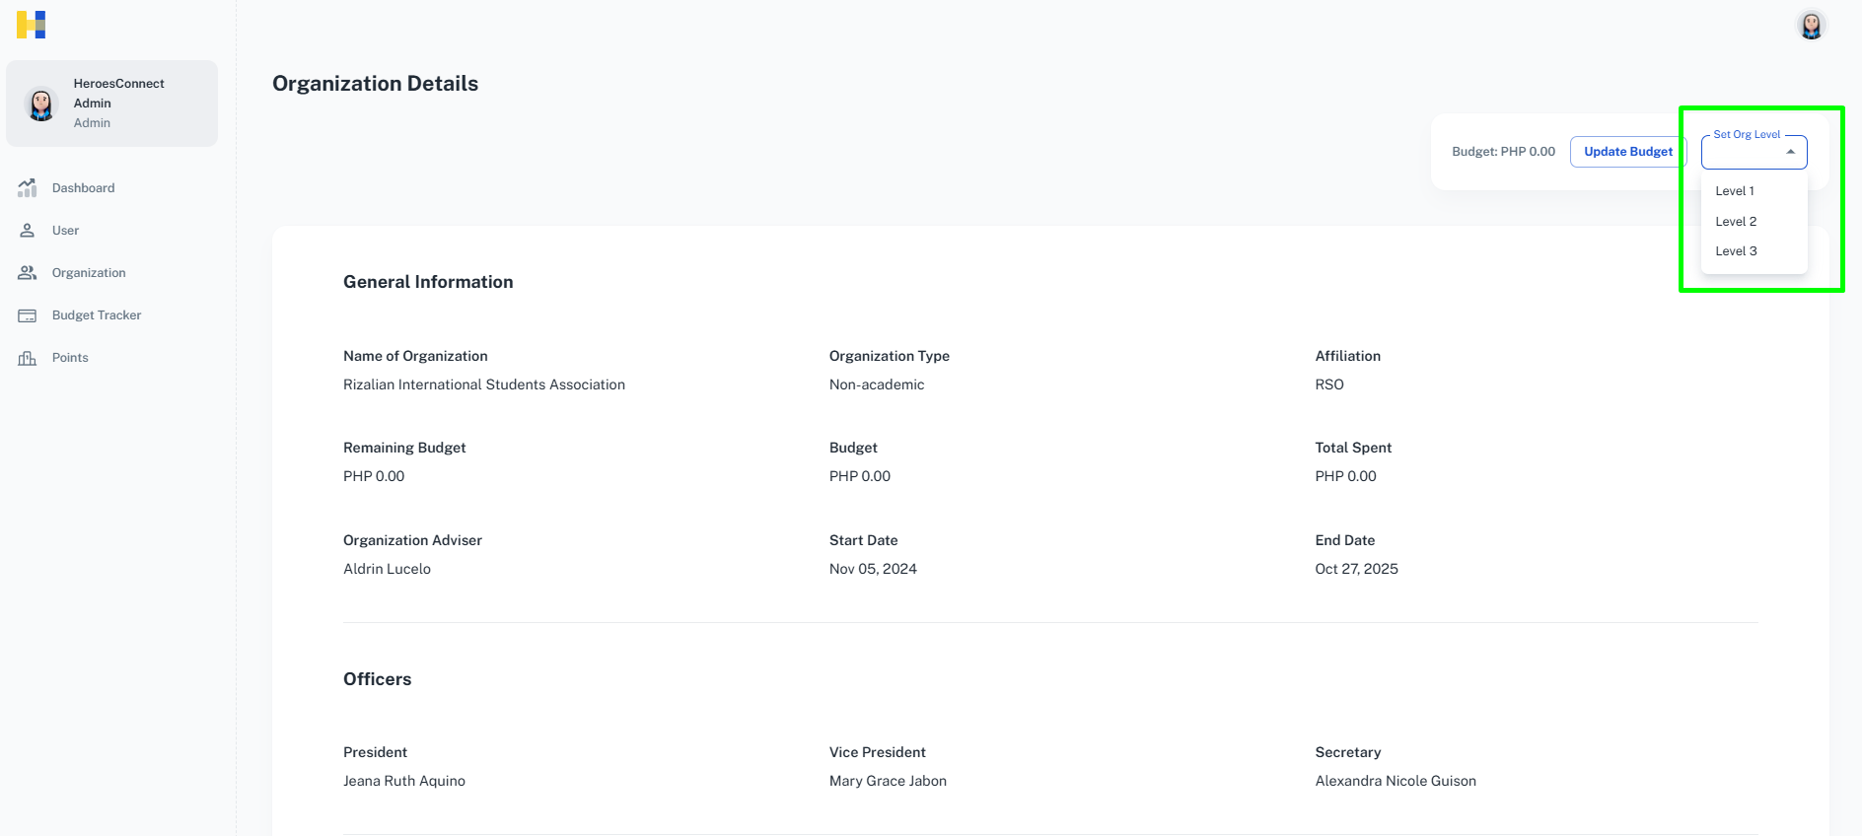

Figure 4.12: Set Organization Level

FFigure 4.13 shows how the staff of the Student Development Office (SDO) uses the Points module to choose proposals for review and assign scores once the activities have ended. The approach makes it possible to evaluate organization proposals fairly and methodically. The staff selects the Points module on the menu, which is intended especially for proposal evaluation. The Student Coordinator sees a list of ideas nominated by various groups under the Points module. The particular proposal that needs to be assessed is chosen by the staff. By clicking the Grade button, the staff will be prompted to the Proposal Details page where they can evaluate the proposal.

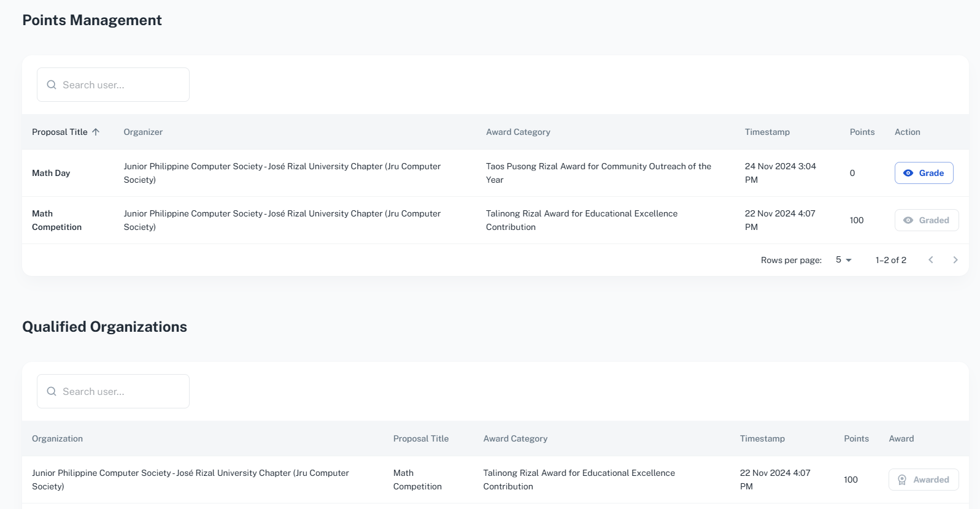

Figure 4.13: Points Management System

To evaluate the selected proposal, the staff will click on the Evaluate button on the upper right side of the screen, as shown in Figure 4.14.

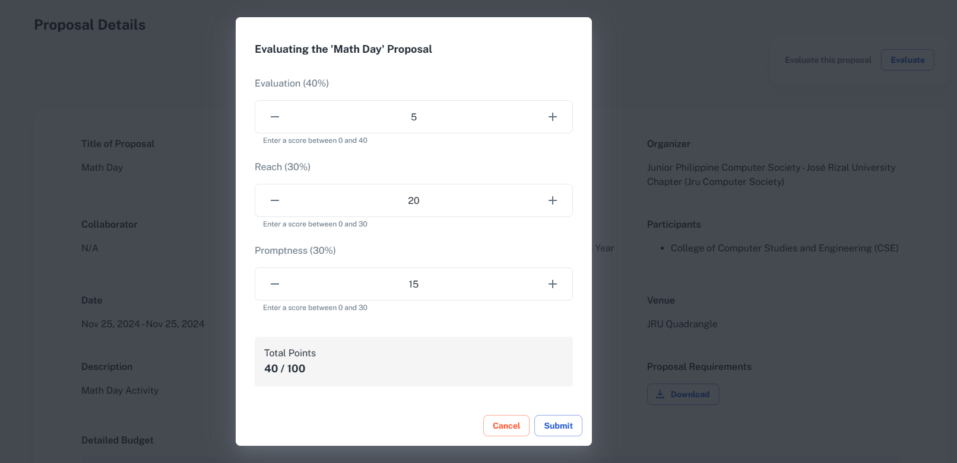

Figure 4.14: Proposal Evaluation

In Figure 4.15 the proposal is then assessed by the Student Coordinator by giving several criteria scoring. The staff completes the evaluation by clicking the Submit button after scoring is finished. The evaluation status of the proposal is then updated when the system logs the scores.

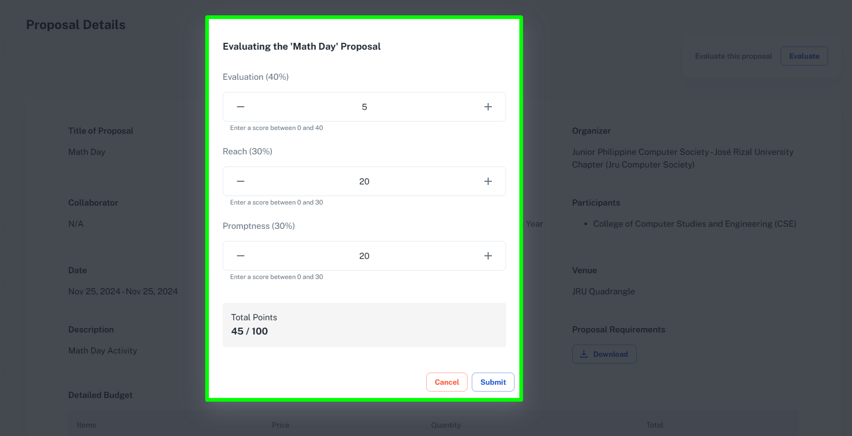

Figure 4.15: Proposal Evaluation - Continuation

TThe Award Organization feature, as shown in Figure 4.16, is designed to streamline the process by which the SDO (Student Development Office) staff can recognize and reward organizations for their achievements. This feature allows the Student Coordinator or the respective user to award qualified organizations based on a points-based system. Organizations accumulate points for meeting specific criteria or achieving set goals, and once they reach a certain threshold, they become eligible for certification. The system automates the tracking and calculation of points, making the awarding process more efficient, transparent, and fair. By leveraging this feature, the Student Coordinator can easily identify deserving organizations and ensure timely and accurate distribution of certificates.

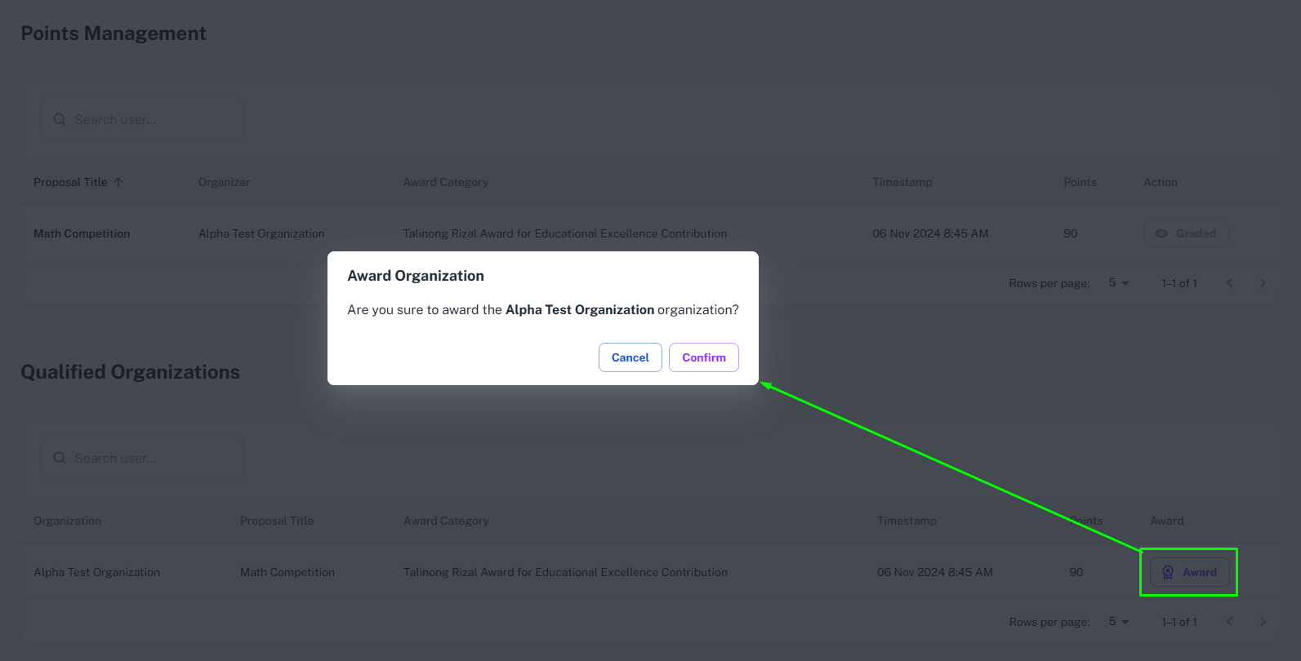

Figure 4.16: Award Organization

The pointing system is based on the evaluation form (Appendix D) provided by the SDO, where organizations can nominate 2 proposals under these categories: Talinong Rizal Award for Educational Excellence Contribution, Talentong Rizal Award for Outstanding Achievement, Tatag Rizal Award for Collaboration Excellence and Taos Pusong Rizal Award for Community Outreach of the Year.

The system is equipped to send email notifications to its users. Email notifications are essential to enhance communication and keep users informed about critical updates. Figures 4.17, 4.18, and 4.19 show the email notification received by an Organization Officer and Adviser about their accounts and password reset request.

Once a new account has been created, the system will also prompt the user to reset its password, as shown in Figure 4.17.

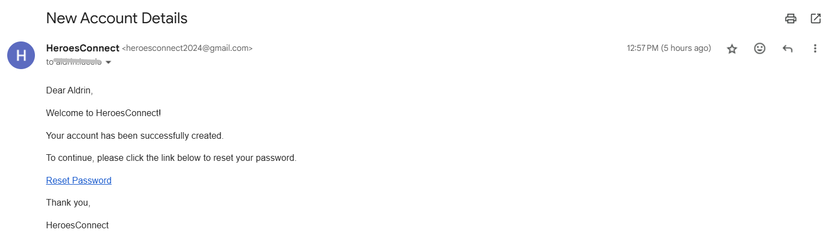

Figure 4.17: Email for New Account Details

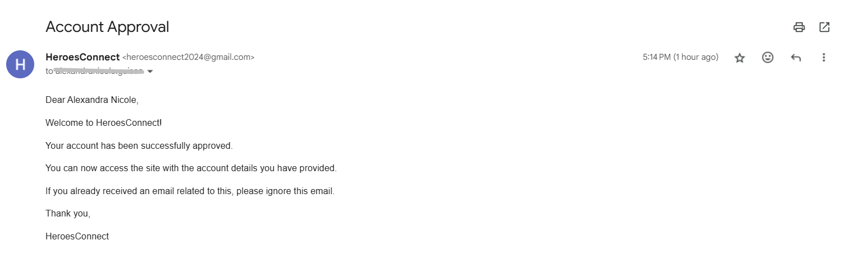

Figure 4.18: Email for Account Approval

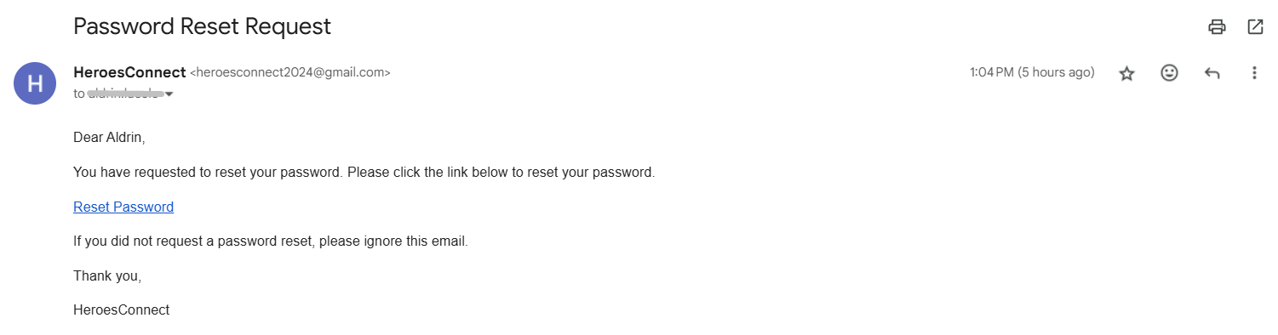

Figure 4.19: Email for Password Reset Request

A few screenshots of email notifications for Proposal Submission are shown in Figure 4.20 and an email notification received by an approver is shown in Figure 4.21.

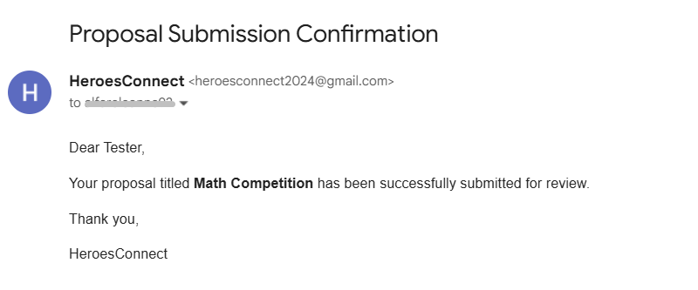

Figure 4.20: Email for Proposal Submission

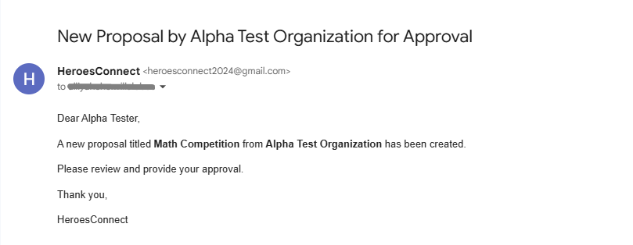

Figure 4.21: Email for Proposal for Approval

Once the proposal has been approved, an email for the approved proposal will be received by the officer, as shown in Figure 4.22. This informs the officer that the proposal has been approved by all the approvers and they can now proceed to the next steps as outlined by the organization or department.

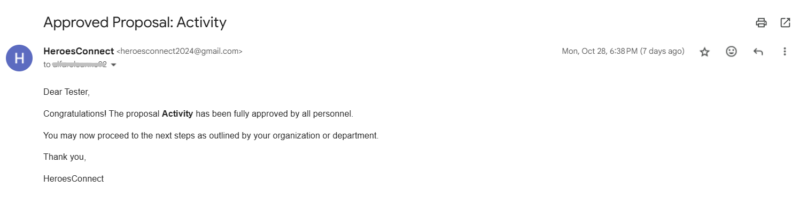

Figure 4.22: Email for Approved Proposal

Officers will be updated and notified once their budget has been updated. Figure 4.23 is the email received by an officer informing about the updated budget of their organization. This email will be triggered once the admin sets or updates the organization's budget.

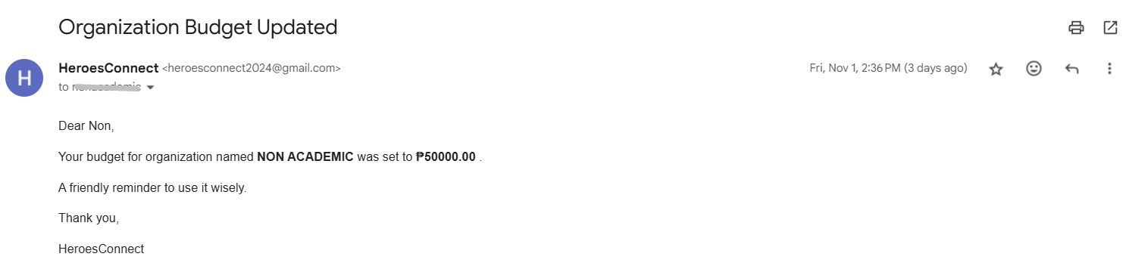

Figure 4.23: Email for Updated Budget

The researchers add a feature to inform officers of the requirement to submit Post-Activity Requirements. Figure 4.24 shows the email notification received by the officer, reminding them to submit these requirements. This email is triggered when the Student Coordinator or Director clicks the Audit button, which is located in the Dashboard section of the web application. The Audit functionality operates daily; for example, if a proposal expires at 5:00 PM (based on the proposal's end date), it will not appear in the Audit list until the following day. This approach allows organizations a period of rest after their activity before they are notified to submit their Post-Activity Requirements.

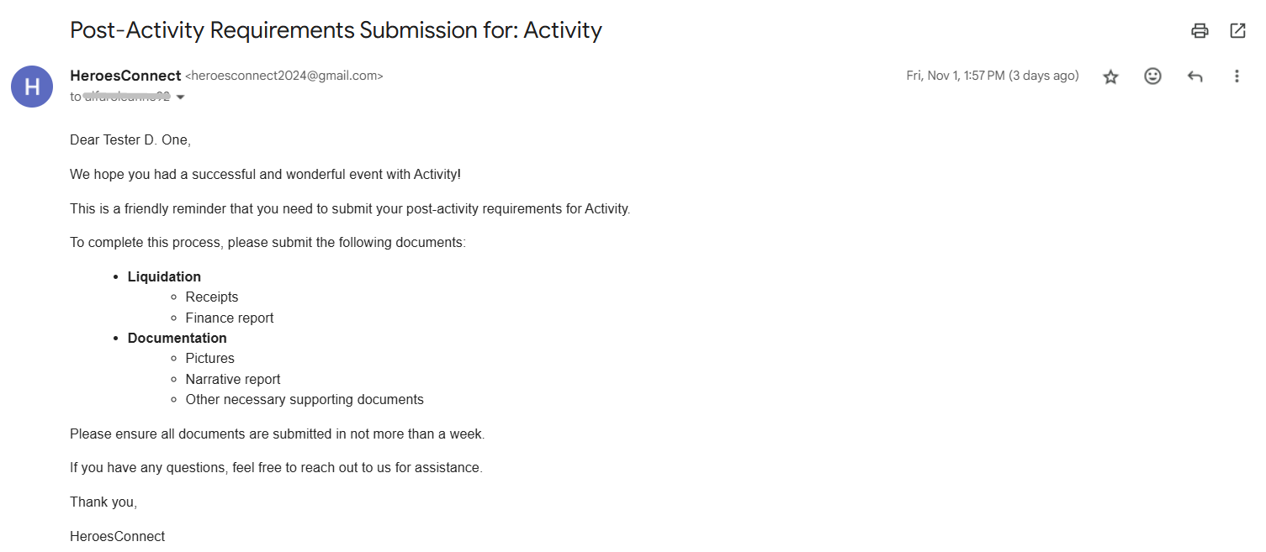

Figure 4.24: Email for Post Activity Requirements Submission

**Develop interactive data visualizations, analytics dashboards, and custom reports using descriptive analytics to enhance decision-making.**

The researchers developed a dashboard (Figure 4.25) that gives a complete view of important numbers and actions happening in the system. This helps the users handle and watch how well the organization is doing. At the top of the dashboard, you can see general information like the total number of proposals, organizations, applications waiting to be approved, and users.

A feature of the dashboard is the Budget vs. Expenditure chart, which visualizes the financial data for each organization, comparing the budget, credit limit, and actual spending. This section allows the personnel (approvers) to monitor the organization's financial health, helping them to manage funds efficiently and prevent overspending.

To the right, a pie chart displays the Current Users distribution by role (e.g., Students, Organization Advisers, Department Chairs, Student Coordinator, SDO Director, Admin). This breakdown aids administrators in understanding the composition of users within the system, providing insights into engagement levels across different roles.

At the bottom, the Top Organizations section highlights organizations that have achieved the highest points, promoting a sense of competition and recognition for active participation. Additionally, the Proposals section lists ongoing proposals with an associated Audit button. The Audit functionality allows Student Coordinators or Directors to review proposals post-expiration, which helps maintain accountability and ensures that post-activity requirements are submitted on time.

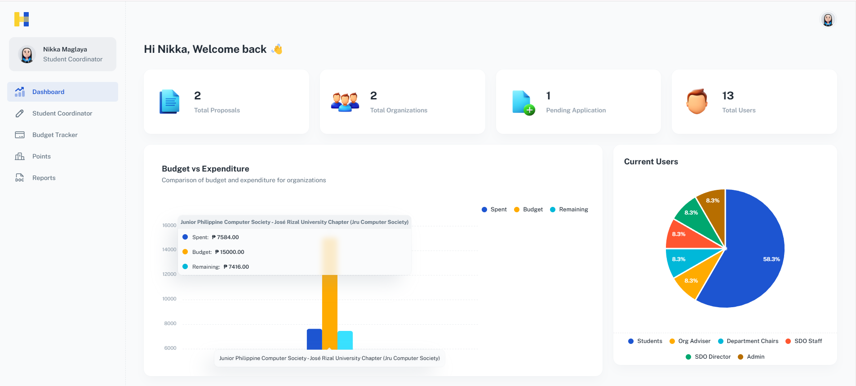

Figure 4.25: Dashboard

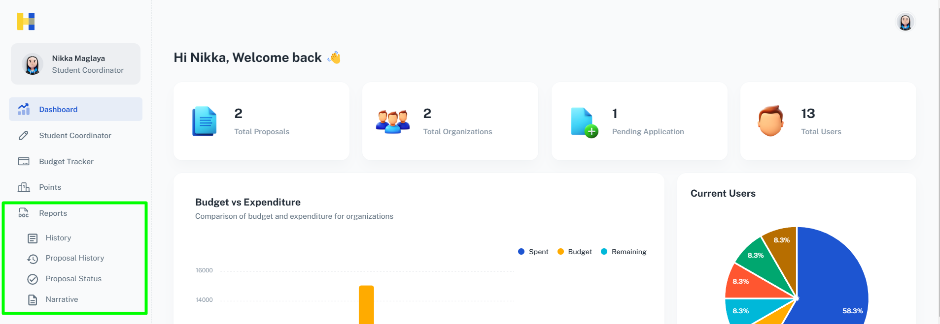

Figure 4.26: Reports

**Set up a secure *web* storage space, which would be used in keeping and reading proposals, reports, and other relevant documents to guarantee the safety and validity of data.**

The researcher's objective is to set up a secure storage solution for managing proposals, reports, and other important documents. This system will ensure that all data remains safe, valid, and easily accessible to authorized users.

Initially, the plan was to implement a secure cloud storage system. However, the researchers have made a strategic shift to using a Web-based MySQL database hosted on the Hostinger plan. This database provides a secure environment for storing documents while offering high performance and reliability. The plan comes with several advanced security features such as DDoS protection, firewalls, SSL encryption, and SQL injection prevention. These features are essential for maintaining data confidentiality and integrity, ensuring that sensitive documents are protected from unauthorized access and external threats.

**Assess the system's effectiveness by measuring ease of use, approval workflow efficiency, notification response times, user engagement, data management satisfaction, and cloud infrastructure reliability through user surveys, system logs, and performance metric.**

The Alpha testing phase was designed to assess the initial features, performance, and compatibility of the HeroesConnect system using specific quality standards. As seen in Table 4.1, the system was well-received in all areas, with an overall score of 3.63, indicating a strong level of satisfaction.

**Table 4.1**

**Alpha Test Summary**

| **Criteria** | **Weighted Mean** | **Verbal Interpretation** |
| --- | --- | --- |
| **Functional Suitability** | 3.67 | Strongly Agree |
| **Performance Efficiency** | 3.62 | Strongly Agree |
| **Compatibility** | 3.53 | Agree |
| **Usability** | 3.82 | Strongly Agree |
| **Reliability** | 3.58 | Agree |
| **Security** | 3.56 | Agree |
| **Maintainability** | 3.60 | Strongly Agree |
| **Portability** | 3.62 | Strongly Agree |
| **Overall Weighted Mean** | 3.63 | Strongly Agree |

One of the best-rated aspects was Usability, which received a score of 3.82. Testers found the system easy to use and navigate, with many saying that its layout and design made tasks simple to finish. This high usability score showed that HeroesConnect was well-designed to meet user needs from the beginning, creating a good first impression.

Functional Suitability got an average score of 3.67, which means the system's main features work well for what it's supposed to do. Testers thought HeroesConnect did a good job meeting the important needs, showing that its basic functions are strong and dependable. Performance Efficiency also did well, with an average of 3.62, meaning the system was quick and handled tasks without any slowdowns or interruptions. Compatibility received a slightly lower score of 3.53 at the “Agree” level. Some of the testers pointed out that while the system is operable on various devices and platforms, it has some small problems while adapting to some of the rare configurations. This shows that there's room for improvement before the Beta test.

Reliability, Security, Maintainability, and Portability all got good scores between 3.56 and 3.62. These scores also pointed towards the fact that the system was stable and secure but at the same time also designed desirably and with the provisions to be easily maintained and manageable to different environments. The mentioned aspects ensured the testers that in the future HeroesConnect can be a sustainable solution.

In summary, the Alpha testing phase highlighted the advantages of HeroesConnect while offering constructive feedback on areas for improvement.. This first testing provided extremely useful insights and gave the basis for further developments and to make sure that the system will be in its best shape for the Beta testing and subsequent phases.

The Beta testing phase was supported by a HeroesConnect presentation organized by the SDO for organization officers on Thursday, November 14, from 1:30 to 4:30 pm, held face-to-face in room H311. Organization leaders were invited to attend, giving them a chance to use the system themselves and give immediate feedback.

According to Table 4.2, the feedback from the organization's leaders was very positive, with an average score of 3.61. People really liked how HeroesConnect met their functional needs, which got a score of 3.62. This score was a bit lower than the last test, but it still showed that the main features of the system were meeting what users expected.

**Table 4.2**

**Beta Test Summary**

| **Criteria** | **Weighted Mean** | **Verbal Interpretation** |
| --- | --- | --- |
| **Functional Suitability** | 3.62 | Strongly Agree |
| **Performance Efficiency** | 3.51 | Agree |
| **Compatibility** | 3.71 | Strongly Agree |
| **Usability** | 3.67 | Strongly Agree |
| **Reliability** | 3.47 | Agree |
| **Security** | 3.62 | Strongly Agree |
| **Maintainability** | 3.60 | Strongly Agree |
| **Portability** | 3.64 | Strongly Agree |
| **Overall Weighted Mean** | 3.61 | Strongly Agree |

Compatibility saw a significant improvement, averaging 3.71, showing that the changes made since the Alpha phase were effective. This higher score indicated that the system worked well on different devices and in various settings, which impressed the organization's officers. Usability, another strong point, scored 3.67. Many participants liked the easy-to-use interface, which made it simple for them to move around and use the platform.

Reliability, with an average score of 3.47, was still well-regarded, although some officers pointed out occasional spots where stability could be improved. On the other hand, Security and Maintainability both got strong scores of 3.62 and 3.60. These scores showed that the system is strong and easy to maintain, giving users confidence that HeroesConnect will be a secure and manageable tool over time.

The presentation not only confirmed the system's strong points but also gave useful ideas and recommendations on how HeroesConnect can keep improving to better serve its users. The feedback from this event highlighted the importance of being flexible and designing with the users in mind, which helps create a dependable platform for the organization's community.

**Chapter 5**

## **SUMMARY, CONCLUSIONS, AND RECOMMENDATIONS**

This chapter summarizes key findings derived from the implementation of the system and user feedback on the effectiveness of the platform in streamlining event proposal workflows, improving approval processes, and promoting transparency in student organization management at Jose Rizal University. The conclusions drawn here reflect the impact of applications on streamlining event management, approval workflows, budget tracking, and communication among stakeholders.

Recommendations follow that describe improvements based on the observation of user interactions, system limitations, and Agile development results. These recommendations would direct further development to keep HeroesConnect evolving with the Student Development Office of Jose Rizal University and its affiliated organizations toward a collaborative and efficient environment for student engagement.

**Summary**

The HeroesConnect platform effectively achieved the goal of centralizing event proposal submission. The system streamlined the documents that student organizations submitted for proposals. The proposal detailed form ensured all basic information, including the details of events, budget requests, and supporting documents, was in one location, thus definitely reducing administrative overload and improving the proposals produced.

HeroesConnect also successfully automated the event proposal approval workflow, enhancing coordination among organization officers and approvers. The system facilitated timely reviews and ensured compliance with university guidelines by integrating a sequential approval flow involving the Organization Adviser, Department Chair, Dean, and SDO. The real-time proposal tracker promoted transparency, allowing users to monitor the status of their submissions and fostering accountability at each approval stage.

HeroesConnect addressed the need for transparent financial oversight through its Budget Tracker module. Organization officers and approvers could track, update, and manage budgets aligned with each event's needs and organizational accreditation levels. This feature promoted fiscal responsibility and reduced the potential for fund misallocation, ensuring that budget adhered to university policies and accurately reflected organizational spending capacities.

This feature improved communication and made the proposal process more responsive and transparent by enabling approvers to give prompt, helpful feedback within the system. The system had proven highly effective in optimizing workflows, promoting user involvement, and guaranteeing data security and accessibility. It included secure web-based storage for document management, real-time alerts to keep users informed, interactive dashboards, and customized reports for data-driven decision-making.

HeroesConnect was created using the Agile methodology and the Scrum framework within iterative cycles with continuous feedback and refinements. Therefore, it was ensured that the platform was aligned according to the requirements of the Student Development Office and organization officers. Each test and interview presented opportunities for enhancement based on user feedback, resulting in a system that met operational needs and was adaptable to evolving requirements.

**Conclusions**

In summary, the main goals of the study, which included creating an integrated system for submitting event proposals and documents, facilitating the approval process, and assessing the organization, were effectively met. The researchers developed a control system providing notifications in real time. The researchers created an efficient mechanism through which users could submit, follow up, and approve event proposals. This reduced workflow bottlenecks and enhanced the level of transparency.

In order to enhance the ability to make evidence-based decisions, the analysts also designed and generated customized reporting pages, business intelligence tools and interactive graphics utilizing descriptive analytics. Such capabilities enabled stakeholders to track engagement, assess performance metrics and better manage organizational activities which in return enabled better decisions across all the business hierarchy.

In order to enhance risk of loss of data availability and consistency, the system also provided for a proper storage for the proposals, reports and any other relevant documents. This setting also guaranteed that retrieval and analysis of sensitive information could be done in a short period of time and whenever necessary.

Finally, the evaluation carried out by the researchers confirmed the effectiveness of the system since the users reported high levels of satisfaction with the operational elements, the user interface, the improved approval workflow and the quick response times. It can therefore be concluded that this particular solution has greatly improved the overall performance for event proposals of the Jose Rizal University Organization.

**Recommendations**

The developers propose the following recommendations to the system:

* Should implement of the new proposal form.
* Should implement of "Save as Draft" in Proposal creation.
* Should implementation of multiple category nominations for proposals.
* Should implementation of resetting awards, when the School Year ends, requires job tasks and automation.
* Should implement of "view" functionality for submitted supporting documents.
* Should Improve in Dashboard. Including historical records and graphical reports of budget and expenses.
* Should Improve in system notification feature.
* Should Improve in email notifications to add additional reminders for user approval (e.g., email alerts on the nearing proposal deadline)
* Should Improve in feedback textbox.
* Should Improve in Organization Application workflow.
* Should Implement a feature to maintain historical records and generate graphical reports of budgets and expenses.
* Should Implement delegation, where the Adviser should step in in the absence of the lead Adviser. The tasks or responsibilities are automatically reassigned to the next available Adviser to maintain workflow continuity.
* Should Implement an option to reassign approvers for each step in the proposal process. This feature ensures that if the designated approver, such as the Lead Adviser, is unavailable, another qualified individual, such as an Assistant Adviser, can be assigned to approve the steps without delaying the workflow.

**References**

| [1] | A. Lathifah, "Linkedin," How Student Organizations Create Wider Impact Through Strategic Partnerships - A Case Study, 24 February 2023. [Online]. Available: https://www.linkedin.com/pulse/how-student-organizations-create-wider-impact-through-ari-lathifah. [Accessed 19 March 2024]. |
| --- | --- |
| [2] | B. Arisoy and Beykent University, "researchgate.net," Digitalization in education, May 2022. [Online]. Available: https://www.researchgate.net/publication/361237342_Digitalization_in_education. [Accessed 22 March 2024]. |
| [3] | I. Kosovska, M. Hallova, I. Vartova, E. Silerova, K. Hennyeyova and P. Cihelka, "AgEcon Search," The Digital Economy in the Context of Digital Transformation and Their Impact on the Electronification of Accounting Processes in the Slovak Republic, 2022. [Online]. Available: https://ageconsearch.umn.edu/record/330104/?v=pdf. [Accessed 1 April 2024]. |
| [4] | M. Lopez-Norez, J. J. Pazor-Arias, A. Golcu and O. Kavrar, "MDPI," Digital Technology in Managing Erasmus+ Mobilities: Efficiency Gains and Impact Analysis from Spanish, Italian, and Turkish Universities, 29 September 2022. [Online]. Available: https://www.mdpi.com/2076-3417/12/19/9804. [Accessed 25 March 2024]. |
| [5] | A. Ab Aziz, Z. M. Yusof, U. A. Mokhtar, and D. I. Jambari, "The implementation guidelines of digital document management system for Malaysia public sector: Expert review," *International Journal on Advanced Science, Engineering and Information Technology*, vol. 10, no. 1, pp. 198-204, 2020. [Online]. Available: https://pdfs.semanticscholar.org/8f2b/638e68b2feb37f19e0f13d2e541413933865.pdf |
| [6] | W. Witanti and Falahah, "Perancangan Sistem Informasi Monitoring Proyek Pembangunan Software dengan Pendekatan CBSE Success factors for E-Learning View project Model of Self-healing software for Business Process View project," in *Seminar Nasional APTIKOM (SEMNASTIK) 2019*, APTIKOM, 2019. [Online]. Available: https://www.researchgate.net/publication/343814480 |
| [7] | A. S. Greeshma and J. B. Edayadiyil, "Automated progress monitoring of construction projects using Machine learning and image processing approach," *Materials Today: Proceedings*, vol. 65, pp. 554-563, 2022. [Online]. Available: https://www.sciencedirect.com/science/article/abs/pii/S221478532201 |
| [8] | T. Cao, "Research and implementation of budget management integration system based on data resource fusion," in *Seventh International Conference on Mechatronics and Intelligent Robotics (ICMIR 2023)*, vol. 12779, pp. 590-596, SPIE, September 2023. Available at SSRN: https://ssrn.com/abstract=2725317 |
| [9] | R. Kapur, "The significance of reward management in organizations," International Journal of Information, Business and Management, vol. 14, no. 2, pp. 83-92, 2022. [Online]. Available: https://www.researchgate.net/profile/Wilbert-Manyanga/publication/361739214 |
| [10] | T. Susnjak, G. S. Ramaswami, and A. Mathrani, "Learning analytics dashboard: a tool for providing actionable insights to learners," International Journal of Educational Technology in Higher Education, vol. 19, no. 1, p. 12, 2022. [Online]. Available: https://link.springer.com/article/10.1186/s41239-021-00313-7 |
| [11] | W. Istiono and J. Sampurna, "Notification information system android-based for spreading school information," Telkomnika (Telecommunication Computing Electronics and Control), vol. 19, no. 3, pp. 747-753, 2021. [Online]. Available: http://doi.org/10.12928/telkomnika.v19i3.18326 |
| [12] | S. Wang, X. Wang, and Y. Zhang, "A secure cloud storage framework with access control based on blockchain," IEEE Access, vol. 7, pp. 112713-112725, 2019. [Online]. Available: https://ieeexplore.ieee.org/abstract/document/8770246 |
| [13] | Astari, D. A. P., Wahyuddin, M. I., & Hidayatullah, D. (2020). Designing the Quality Assurance Agency E-Document Application at the National University Website Based: Designing the Quality Assurance Agency E-Document Application at the National University Website Based. Jurnal Mantik, 4(2), 1100-1106. https://doi.org/10.35335/mantik.Vol4.2020.895.pp1100-1106 |
| [14] | Triyana, M. H., & Fianty, M. I. Optimizing Educational Institutions: Web-Based Document Management. https://www.researchgate.net/publication/377667451_Optimizing_Educational_Institutions_Web-Based_Document_Management |
| [15] | F. G. P. Susanto, N. I. Y. Fadlan and P. Haryani, "Design of Web-Based Management Information System for Student Organizations in Kendal Regency Using Next.js Framework," Design of Web-Based Management Information System for Student Organizations in Kendal Regency Using Next.js Framework, May 2023. |
| [16] | C. P. Noguerra Jr., "Designing a User-Centric School Organizational Club Application System: Development and Evaluation," Designing a User-Centric School Organizational Club Application System: Development and Evaluation, May 2023. |
| [17] | P. Mangesh, G. Shelkikar, M. Mehta, S. Kothari, and K. Wanjale, "Content Management System," International Journal of Creative Research Thoughts (IJCRT), vol. 9, no. 5, pp. k52-k58, May 2021. [Online]. Available: http://www.ijcrt.org/papers/IJCRT21A6089.pdf |
| [18] | R. P. Soesanto, A. F. Rizana and L. Andrawina, "IJIES," Design of Reporting, Evaluation, and Monitoring Application for Student Organization in University, 1 January 2019. [Online]. Available: Design of Reporting, Evaluation, and Monitoring Application for Student Organization in University. [Accessed 25 March 2024] |
| [19] | F. Moreno and J. Sulasula, "scienceopen," Towards a Regional System of State Universities and Colleges in Zamboanga Peninsula, Philippines, 1 August 2023. [Online]. Available: https://www.scienceopen.com/hosted-document?doi=10.14293/PR2199.000273.v1. [Accessed 25 March 2024]. |
| [20] | M. Z. Iksan and F. Abdussalam, "Jurnal E-Komtek," Design of a Web-Based Personnel Administration Management Information System at Politeknik Piksi Ganesha, 28 June 2023. [Online]. [Accessed 1 April 2024]. |
| [21] | F. Asrin and G. V. Utami, "Journal of Information System And Informatics," Implementing Website-Based School Information Systems in Public Elementary Schools Using Waterfall Model, 5 May 2023. [Online]. [Accessed 1 April 2024]. |
| [22] | V. J. Paucar-León, F. Molina-Granja, R. Lozada-Yánez, and J. C. Santillán-Lima, "Model of Long-Term Preservation of Digital Documents in Institutes of Higher Education," in *International Conference on Knowledge Management in Organizations*, Cham: Springer International Publishing, July 2022, pp. 257-269. [Online]. Available: https://link.springer.com/chapter/10.1007/978-3-031-07920-7_20 |
| [23] | K. Beycioglu and Y. Kondakci, "SageJournals," Organizational Change in Schools, 6 January 2023. [Online]. Available: https://journals.sagepub.com/doi/full/10.1177/2096531120932177#bibr88-2096531120932177. [Accessed 1 April 2024]. |
| [24] | J. Adam, “Agile software development with Scrum,” Sep. 29, 2021. https://kruschecompany.com/agile-software-development-with-scrum-framework/ |
| [25] | “Jose Rizal University,” Philippine Association of Colleges and Universities, https://www.pacu.org.ph/team/jose-rizal-university/ (accessed May 22, 2024). |
| [26] | “ISO 25010.” https://iso25000.com/index.php/en/iso-25000-standards/iso-25010 |
| [27] | D. J. D. Cruz, “ISO-25010-Questionnaires,” Scribd. https://www.scribd.com/document/682512398/ISO-25010-Questionnaires |

[28]Admin, “How to interpret 4-Point Likert Scale results? -,” Oct. 25, 2024. https://chartexpo.com/blog/4-point-likert-scale#

**Appendix A**

**Letter of Permission to Conduct Research**

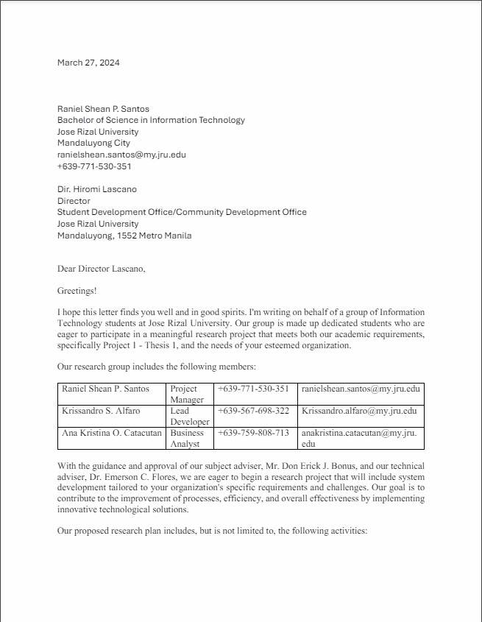



**Appendix B**

**Data Flow Diagram**

**Context Level - Pre-Activity Proposal**

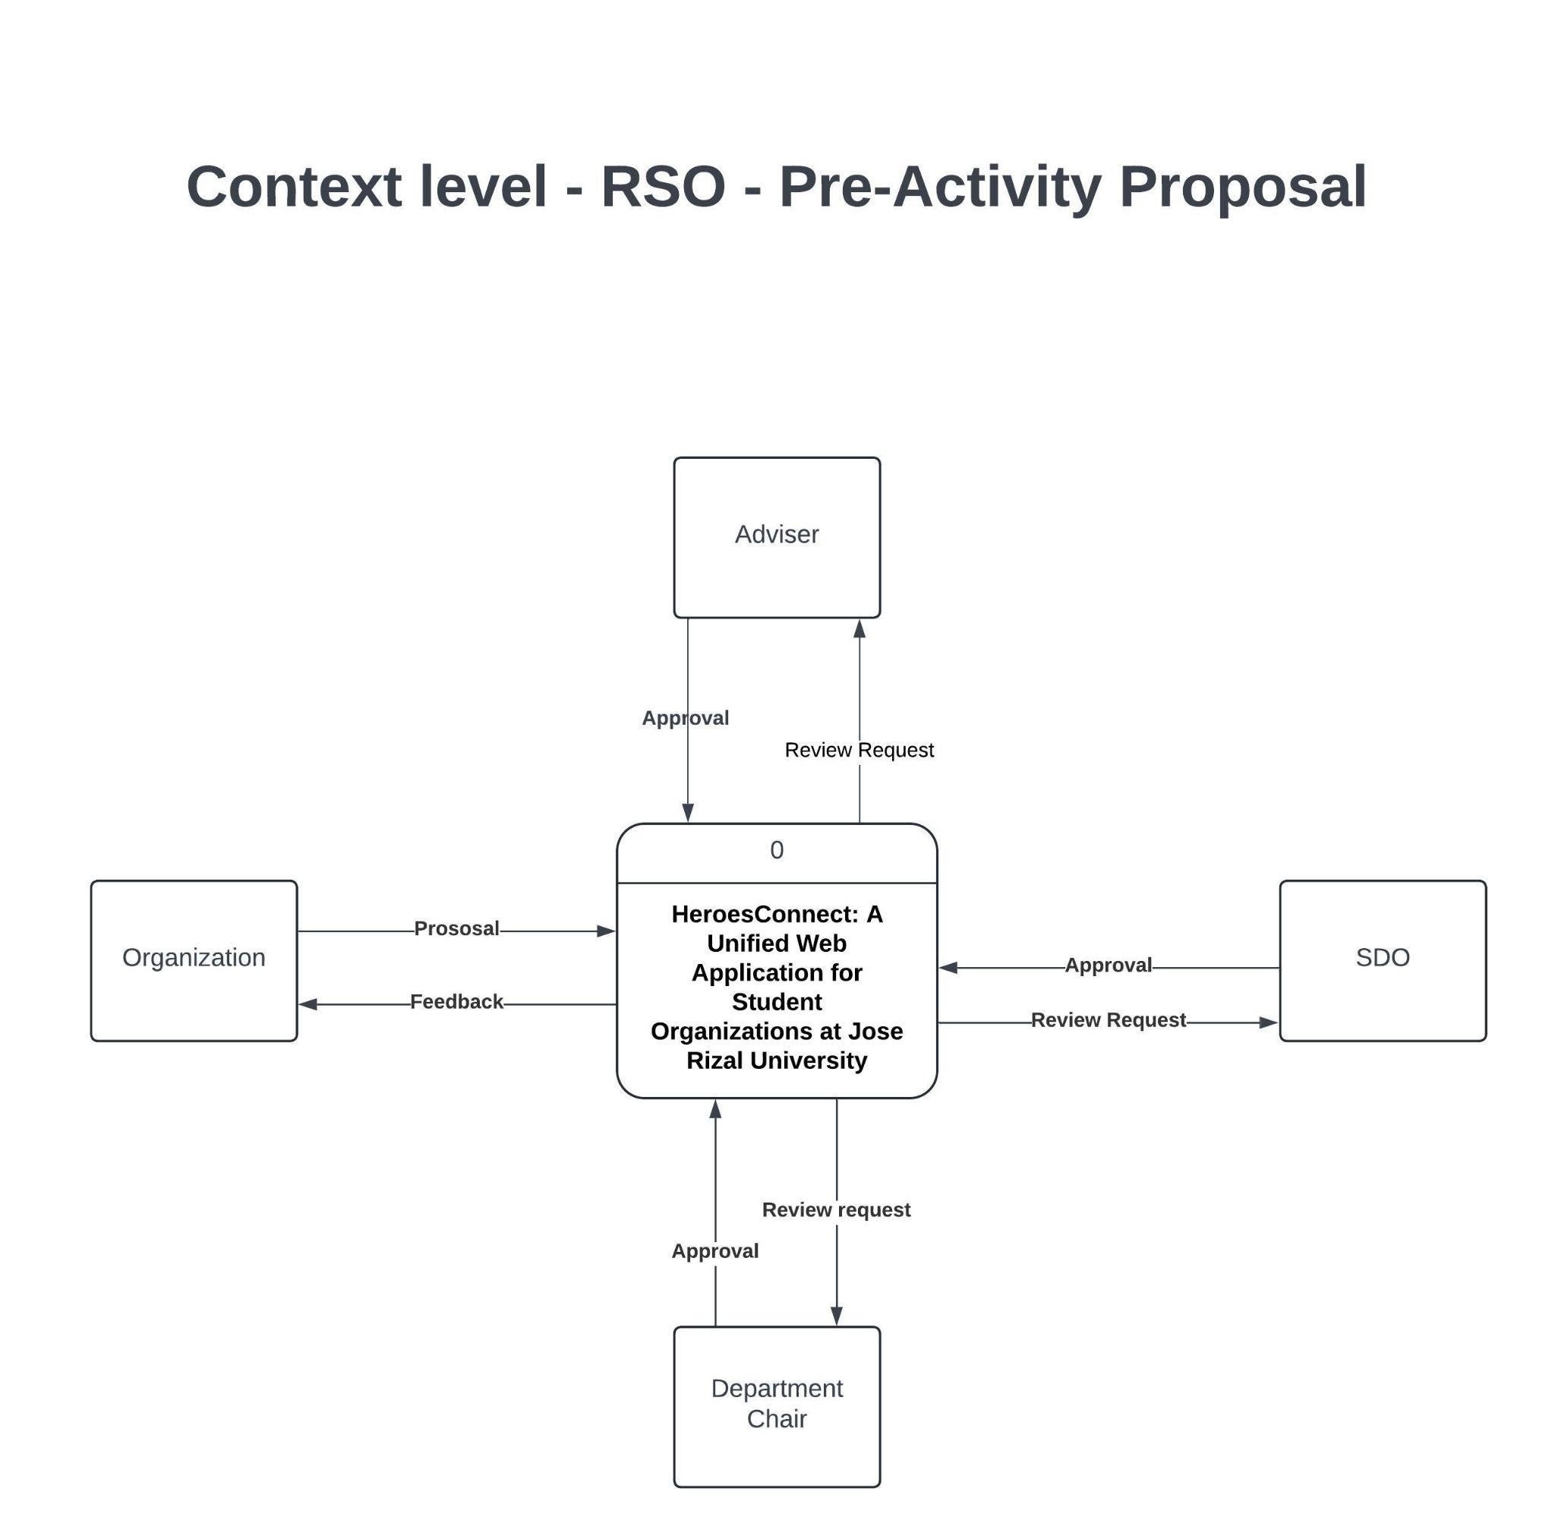

**Appendix B.1**

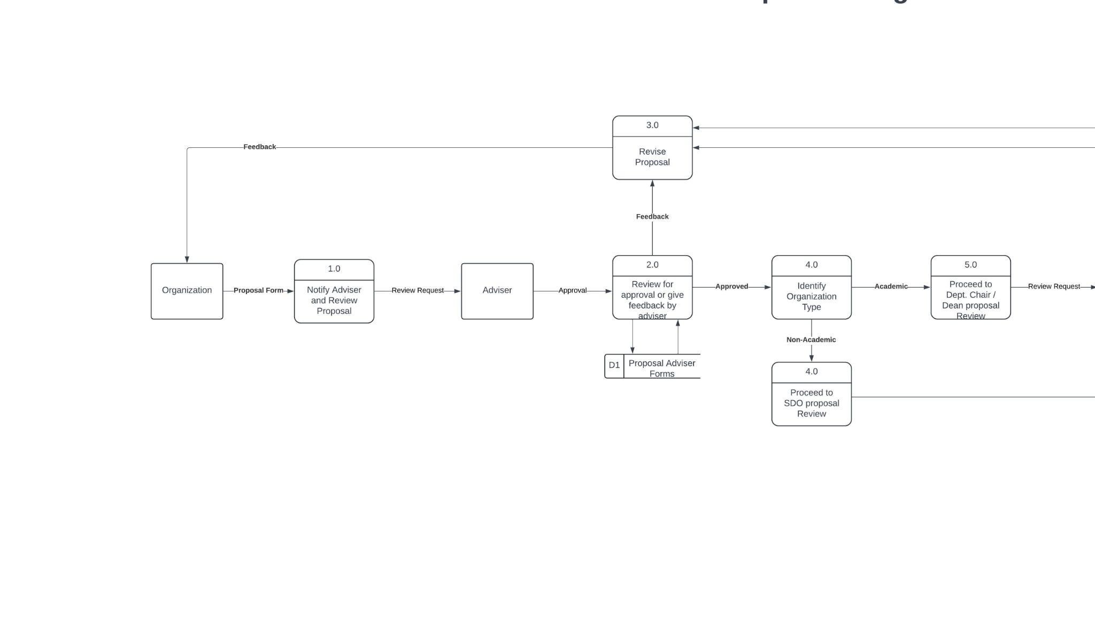

**Top-level Diagram - RSO - Pre-Activity Proposal**

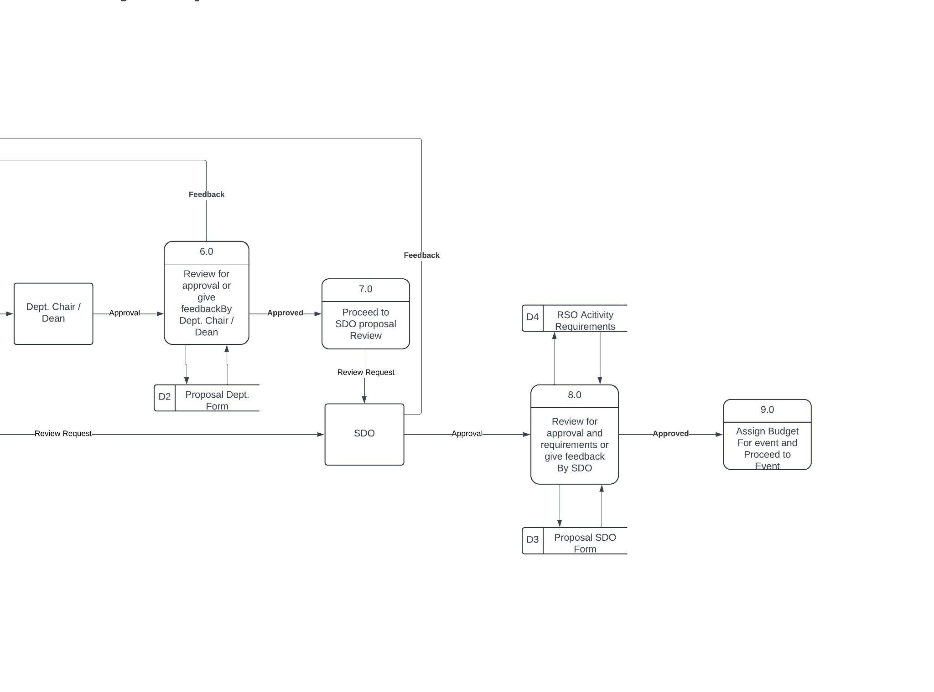

**Appendix B.2**

**Context-level Diagram - Application for Student Organization**

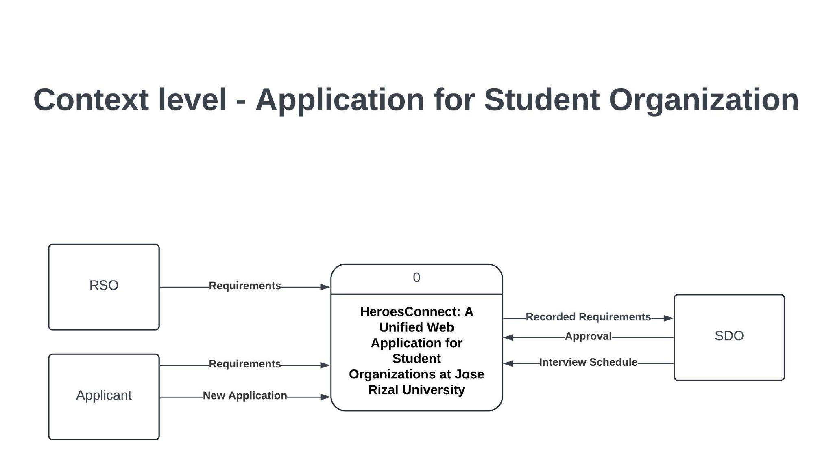

**Top-level Diagram - Application for Student Organization**

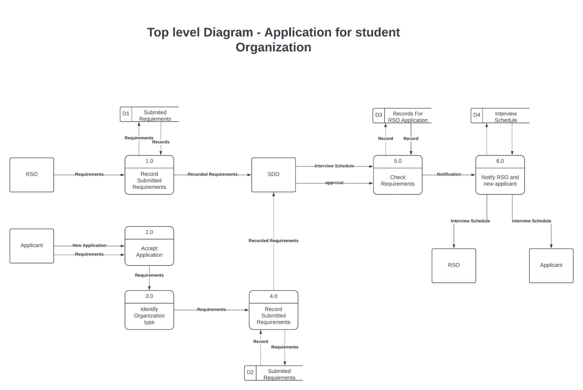

**Appendix C**

**Flow Chart**

**Pre-Activity Approval**

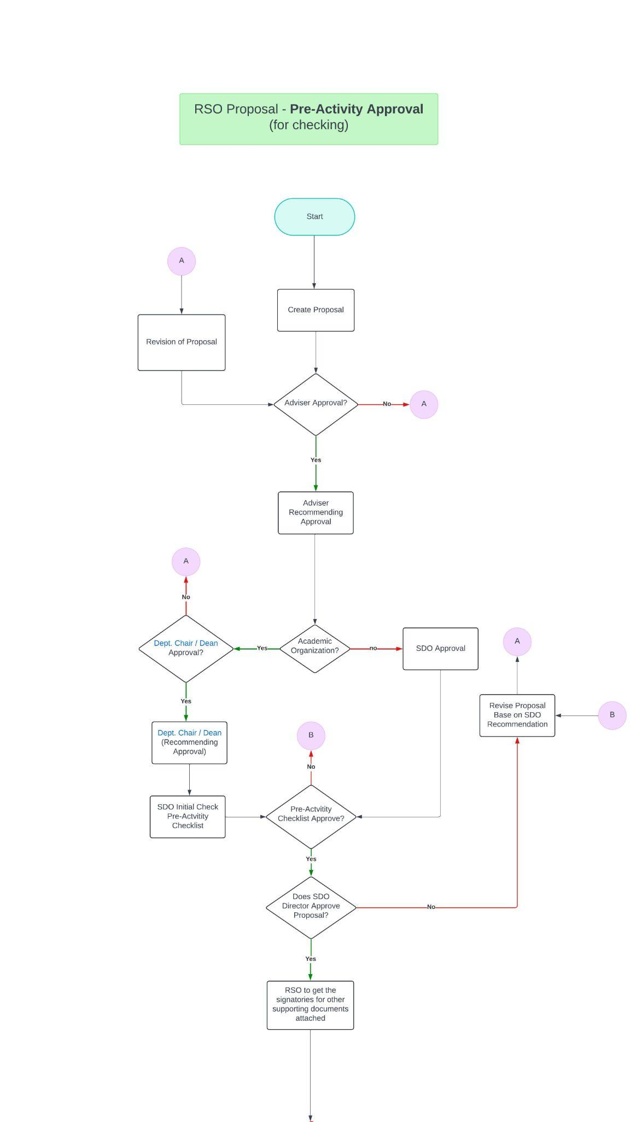

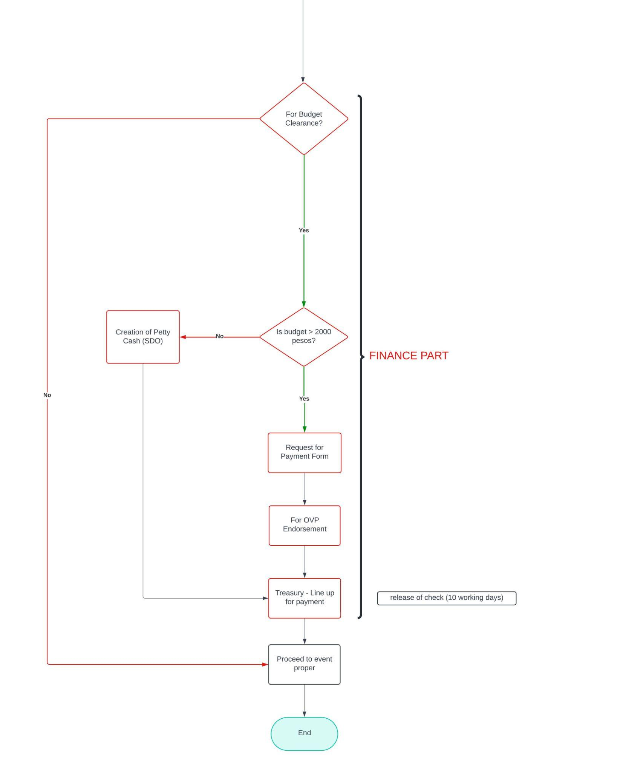

**Appendix C.1**

**Application for Student Organization**

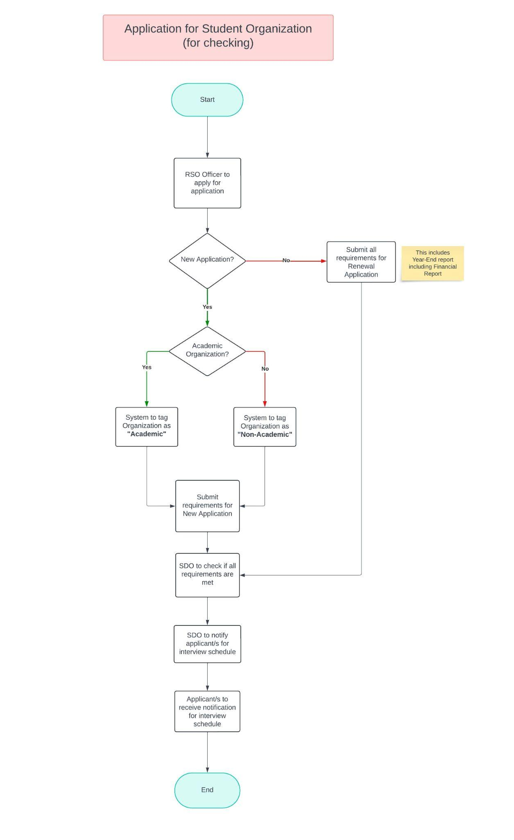

**Appendix C.2**

**Entity Relationship Diagram**

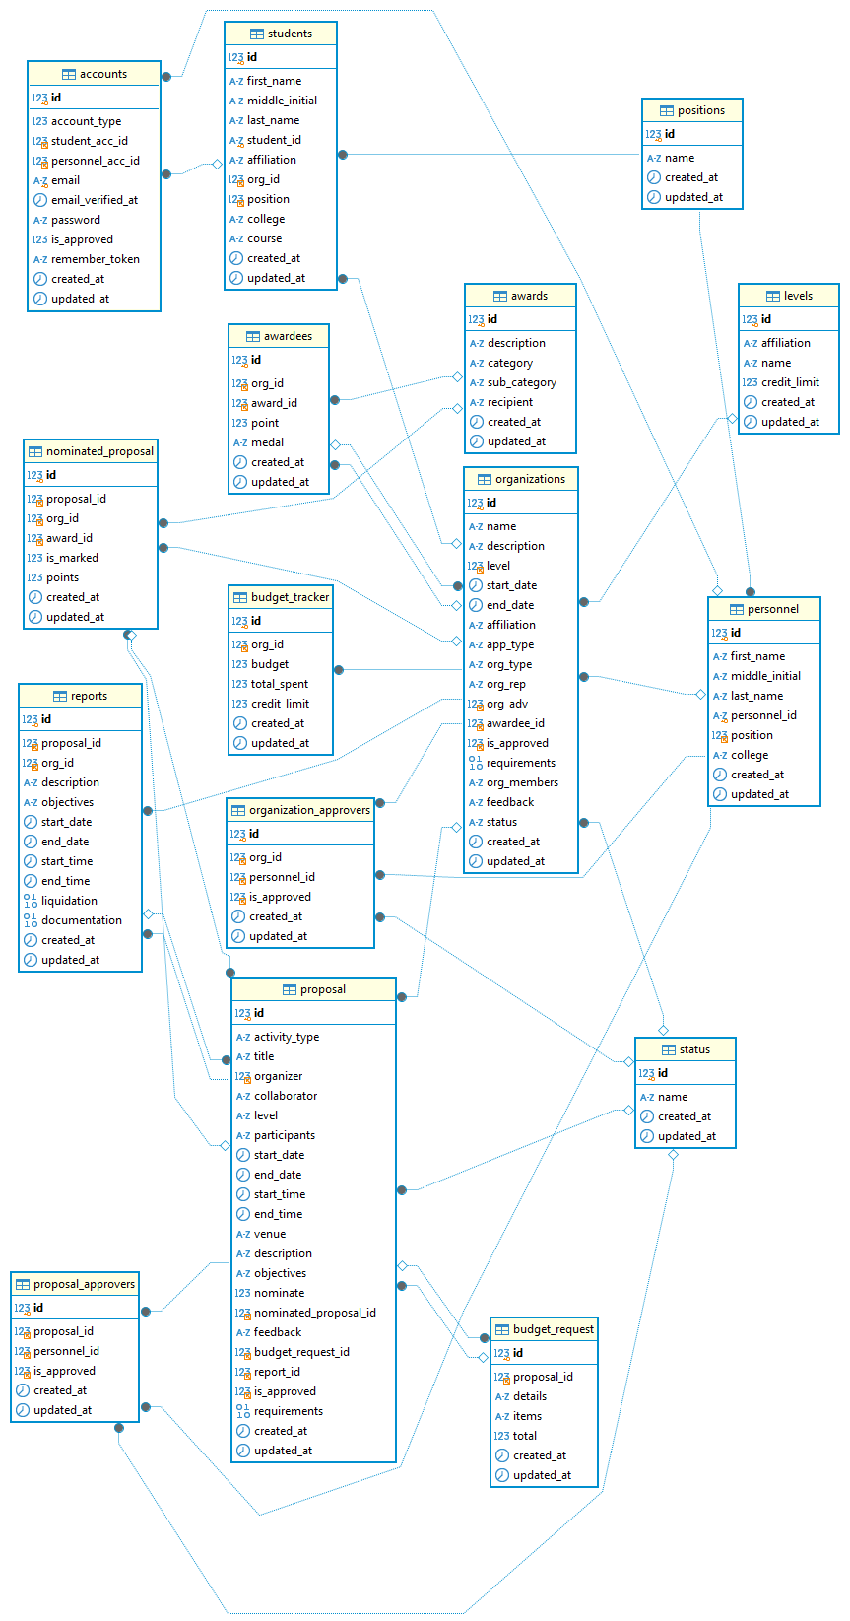

**Appendix C.3**

**Entity Relationship Diagram**

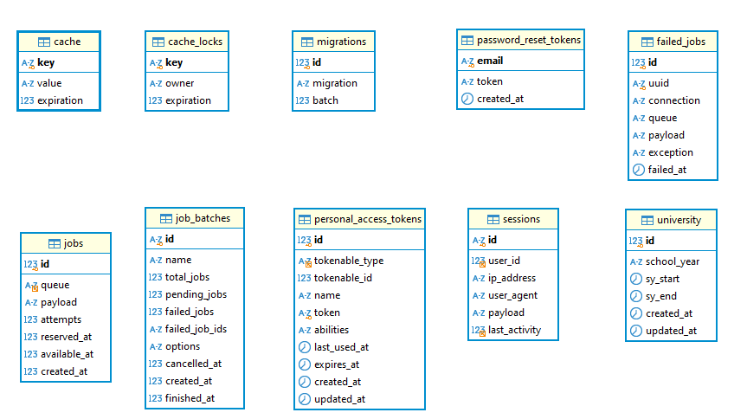

**Appendix D**

**Documents, Memoranda, Data/Figures**

**Evaluation Form**

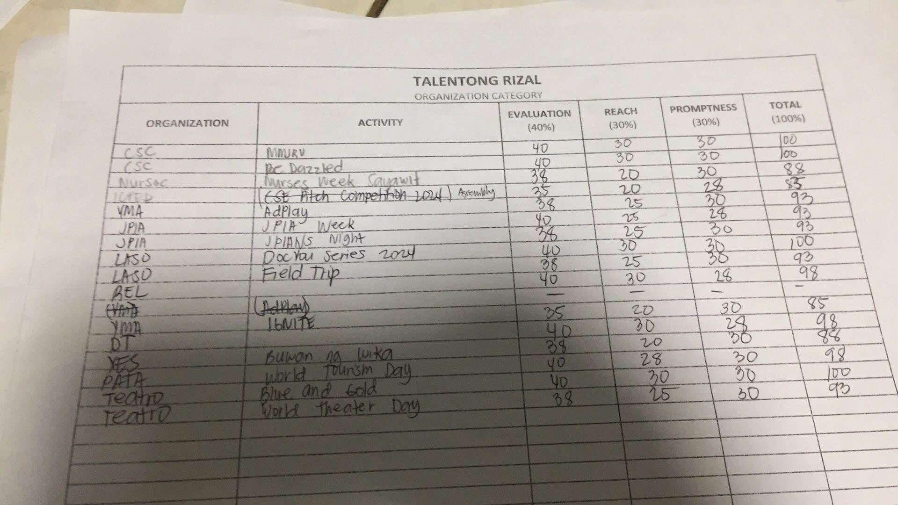

**Appendix D.1**

**Administrator User Manual**

### **Login**

1. Go to <https://heroesconnect.site/>
2. Enter your valid EMAIL ADDRESS and PASSWORD
3. Click the Login button.

### **Dashboard**

1. The **Dashboard** is the landing page.
2. The total count for the following will show:
   1. Total Proposals
   2. Total Organizations
   3. Pending Applications
   4. Total Users
   5. Budget vs. Expenditure is the Comparison of budget and expenditure for organizations
   6. Current Users in Pie Chart view.
3. To update the School Year details, click the SY.
4. Enter the School Year (e.g. 2024-2025)
5. School Year Start
6. School Year End
7. Click the Save Changes button.

### **Users**

1. To create Users, click the Users module.
2. Then click the + New User button.
3. Select User Type: Personnel or Student
   1. Personnel are the Approvers like the Advisers, Dept. Chair, Dean, SDO
   2. Students are the Officers like the President, Vice President and Secretary
4. To Create a Personnel Account, enter and select the following details:
   1. First Name
   2. Middle Initial
   3. Last Name
   4. Email
   5. Personnel ID (e.g: 12-123456)
   6. Position
   7. College
5. Once done, click the Register button.
6. This will send an email notification to the user, prompting them to change their password, and they will be able to access the system.
7. To Create a Student Account, enter and select the following details:
   1. First Name
   2. Middle Initial
   3. Last Name
   4. Email
   5. Student ID (e.g: 12-123456)
   6. Affiliation (RSO or CSC)
   7. Position (PRESIDENT, VICE PRESIDENT or SECRETARY)
   8. College
   9. Course
   10. Status (APPROVED or PENDING)
       1. APPROVED status: The student will have access to the system.
       2. PENDING status: The student doesn't have access to the system for the time being.
   11. Once done, click the Register button.
   12. This will send an email notification to the student, prompting them to change their password, and they will be able to access the system.

### **Organization**

*Please note that to be able to create an organization, make sure that the organization’s Adviser, President, Vice President, and Secretary are already enrolled in the system.*

1. To create an Organization, click the Organization module.
2. Then click the + Organization button.
3. Enter and select the following details:
   1. Name of Organization*
   2. Application Type * (NEW ORGANIZATION or RENEWAL)
   3. Organization Type * (ACADEMIC or NON-ACADEMIC)
   4. Affiliation * (RSO or CSC)
   5. Select the Org Adviser *
   6. Start Date *
   7. Status * (ACTIVE or INACTIVE)
   8. Select the President *
   9. Select the Vice President *
   10. Select the Secretary *
   11. Description *
   12. Requirements - Upload File (Please upload a ZIP file containing all the required documents, including forms, certificate, list of officers, and any other relevant files.)

### **Budget Overview -** *Admin can only view the Budget Overview*

### **Points -** *Admin can only view the Points.*

**Appendix D.2**

**Students/Officers User Manual**

### **Login**

1. Go to <https://heroesconnect.site/>
2. Enter your valid EMAIL ADDRESS and PASSWORD
3. Click the Login button.

*Note: You can sign up by clicking the Sign-Up link. Once submitted, the account will be first reviewed by SDO for approval. Once approved, you will receive an email notification prompting you to change your password. Once done, you can now log in and access the system.*

### **Dashboard**

1. The Dashboard is the landing page.
2. The total count for the following will show:
   1. Total Proposals
   2. Total Organizations
   3. Pending Applications
   4. Total Users
   5. Budget vs. Expenditure is the Comparison of budget and expenditure for organizations
   6. Current Users in Pie Chart view.

### **Organization**

1. To view the Organization details, click the Organization module. Details like:
   1. Name
   2. Organization Type
   3. Level
   4. Remaining Budget
   5. Budget
   6. Total Spent
   7. Organization Adviser
   8. Start Date
   9. End Date
   10. Officers
       1. President
       2. Vice President
       3. Secretary
   11. Other Details
       1. Description
       2. Requirements

### **Adding Members**

*Note: As an Org President, you can add members.*

1. To add members, click the Adding Members module
2. Then click the + New Member button.
3. Click the Add Row button to add another field row
4. Enter the member details.
5. Click the Save Changes button.

### **Proposal**

1. Click the Proposal module.
2. Then click the + Create Proposal button.

Enter the following details:

1. Title of Activity *
2. Type of Activity *
3. Organizer (Org Name)
4. Level *
5. Collaborator *
6. Requirements (Please upload a ZIP file containing all the required documents, including forms, letters, memorandum, and any other relevant files.)
7. Participants & Schedule
   1. Participants *
   2. Venue *
   3. Start Date
   4. End Date
   5. Start Time
   6. End Time
8. Description of Activity *
9. Objectives of Activity *
10. Details of Budget Request *
    1. Item
    2. Price
    3. Quantity
    4. Total (auto-computed)
    5. Click REMOVE - to remove the line item
11. Budget Limit: 15850
12. Total Budget: 0
13. Requested By
    1. President
    2. Secretary
14. Recommending Approval By (Dept. Chair)
15. Click the Submit Application button.

### **Application Status**

*The Application Status module is a tracker that shows the current stage of an organization's application or proposal in the approval process.*

1. Click the Application Status module.
2. Click on a line item to view the tracker

### **Nominate Proposal**

1. After the Approval workflow has been completed (All Approved), the officer can Nominate the proposal for the following categories:
   1. Talinong Rizal Award for Educational Excellence Contribution.
   2. Talentong Rizal Award for Outstanding Achievement
   3. Tatag Rizal Award for Collaboration Excellence
   4. Taos Pusong Rizal Award for Community Outreach of the Year
2. Select the **Category**.
3. Click the Submit button.
4. Once submitted, it will now go through the evaluation process by the SDO.

### **Narrative report (Post-Activity Requirements)**

*Once the proposal has expired (based on the proposal end date) – the SDO can trigger the Post-Activity Requirements Submission. Once triggered by SDO (AUDIT), the officer will receive an email.*

### To upload your Post Activity Requirements, go to your proposal

### Then, upload your files for SDO review.

**Appendix D.3**

**Personnel/Approvers User Manual**

### **Login**

1. Go to <https://heroesconnect.site/>
2. Enter your valid EMAIL ADDRESS and PASSWORD
3. Click the Login button.

### **Dashboard**

1. The Dashboard is the landing page.
2. The total count for the following will show:
3. The Dashboard is the landing page.
4. The total count for the following will show:
   1. Total Proposals
   2. Total Organizations
   3. Pending Applications
   4. Total Users
   5. Budget vs. Expenditure is the Comparison of budget and expenditure for organizations
   6. Current Users in Pie Chart view.

### **SDO Director Approval**

1. To approve proposals Click “SDO Director”
2. Navigate to Proposal Approval
3. Click “View”, After clicking “View” you may see the following information of the proposals from Title of the proposal to the Proposal Approval Status.
4. To Download the Proposal Requirements just click the “Download” button.
5. To give “Feedback”, navigate at the bottom and click on the open space inside the comment box.
6. To Approve, Reject or Revise the proposal, just Click the buttons provided at the bottom of the proposal then click save.

### **Budget Overview** - Viewing of Bugdet per Organization

### **Point System**

1. To give points to a proposal first click on the “Points”.

In the points module you can see the list of proposals and the qualified organizations to be evaluated.

1. To evaluate the proposal, click “View” to view the proposal to be evaluated.
2. On the top right corner of the screen, Click the “Evaluate” button.
3. As you can see there is a corresponding score for each criteria when evaluating the proposal. Make sure that when giving a score the range is within the limit score for each criteria. (Evaluation 0-40, Reach 0-30, Promptness 0-30).
4. After Giving a Score, Click the “Submit” button.
5. The system will display a prompt message stating “The Proposal has been marked successfully”
6. To download the Proposal Requirements just click the “Download’ button in the proposal details

### **Reports**

1. Navigate to the “Reports” module then click.
2. After Clicking the reports module will expand.
3. Proposal History Report
4. Proposal Status Report
5. Narrative Report

### **Profile and Change Password**

1. To see profile click on the bubble head at the top right corner of the screen.

You will see your current email and the “Change Password” setting.

1. To change password click on the “Change Password’ button and fill the necessary data needed. Then click “‘Save password”

### **Log-out**

1. To log-out the account press the profile head then click “Logout” Button.

### **Student Coordinator Login**

1. Go to <https://heroesconnect.site/>
2. Enter your valid EMAIL ADDRESS and PASSWORD
3. Click the Login button.

### **Dashboard**

1. The Dashboard is the landing page.
2. The total count for the following will show
   1. Total Proposals
   2. Total Organizations
   3. Pending Applications
   4. Total Users
   5. Budget vs. Expenditure is the Comparison of budget and expenditure for organizations
   6. Current Users in Pie Chart view.

### **Student Coordinator module**

1. To approve proposals Click “Student Coordinator”
2. Navigate to Proposal Approval
3. Click “View”, After clicking “View” you may see the following information of the proposals from Title of the proposal to the Proposal Approval Status.
4. To Download the Proposal Requirements just click the “Download” button.
5. To give “Feedback”, navigate at the bottom and click on the open space inside the comment box.
6. To Approve, Reject or Revise the proposal, just Click the buttons provided at the bottom of the proposal then click save. See the figure below

### **Budget Overview -** Viewing of Bugdet per Organization

### **Point System**

1. To give points to a proposal first click on the “Points”.

In the points module you can see the list of proposals and the qualified organizations to be evaluated.

1. To evaluate the proposal, click “View” to view the proposal to be evaluated.
2. On the top right corner of the screen, Click the “Evaluate” button.
3. As you can see there is a corresponding score for each criteria when evaluating the proposal. Make sure that when giving score the range is within the limit score for each criteria. (Evaluation 0-40, Reach 0-30, Promptness 0-30).
4. After Giving Score, Click the “Submit” button.
5. The message “The Proposal has been graded” will show

### **Reports**

1. Navigate to the “Reports” module then click.
2. After Clicking the reports module will expand.
3. Proposal History Report
4. Proposal Status Report
5. Narrative Report

### **Dean Module**

1. To approve proposals Click “Dean”
2. Navigate to Proposal Approval
3. Click “View”, After clicking “View” you may see the following information of the proposals from Title of the proposal to the Proposal Approval Status.
4. To Download the Proposal Requirements just click the “Download” button.
5. To give “Feedback”, navigate at the bottom and click on the open space inside the comment box.
6. To Approve, Reject or Revise the proposal, just Click the buttons provided at the bottom of the proposal then click save.

### **Department Chair Module**

1. To approve proposals Click “Department Chair”
2. Navigate to Proposal Approval
3. Click “View”, After clicking “View” you may see the following information of the proposals from Title of the proposal to the Proposal Approval Status.
4. To Download the Proposal Requirements just click the “Download” button.
5. To give “Feedback”, navigate at the bottom and click on the open space inside the comment box.
6. To Approve, Reject or Revise the proposal, just Click the buttons provided at the bottom of the proposal then click save.

### **Adviser Module**

1. To approve proposals Click “Adviser”
2. Navigate to Proposal Approval
3. Click “View”, After clicking “View” you may see the following information of the proposals from Title of the proposal to the Proposal Approval Status.
4. To Download the Proposal Requirements just click the “Download” button.
5. To give “Feedback”, navigate at the bottom and click on the open space inside the comment box.
6. To Approve, Reject or Revise the proposal, just Click the buttons provided at the bottom of the proposal then click save.

### **Profile and Change Password**

1. To see profile click on the bubble head at the top right corner of the screen.
2. You will see your current email and the “Change Password” setting.
3. To change password click on the “Change Password’ button and fill the necessary data needed. Then click “‘Save password”

### **Log-out**

1. To log-out the account press the profile head then click “Logout” Button.

**Appendix D.4**

**HEROESCONNECT PRESENTATION TO ORGANIZATION OFFICERS**

**(F2F-H311) Thursday, November 14 | 1:30 – 4:30pm**

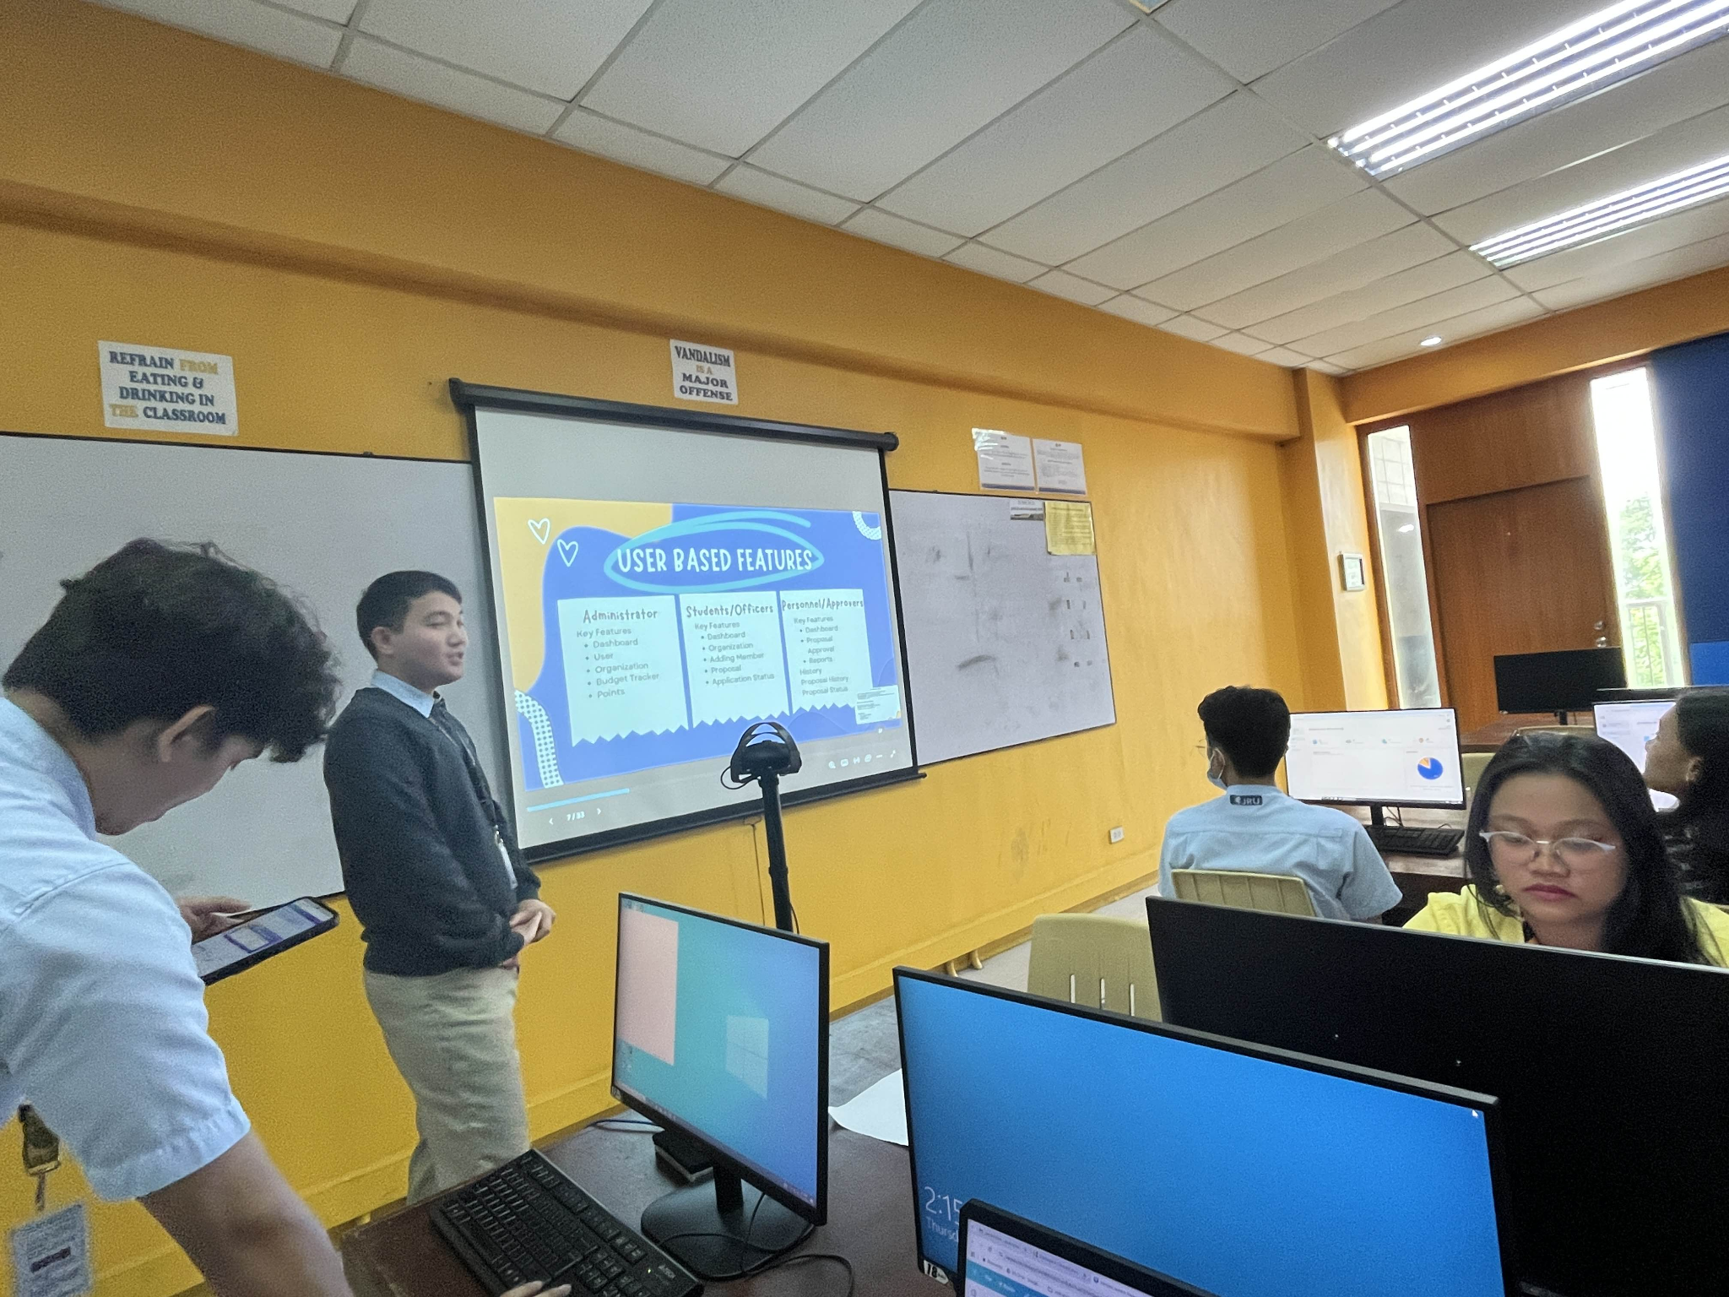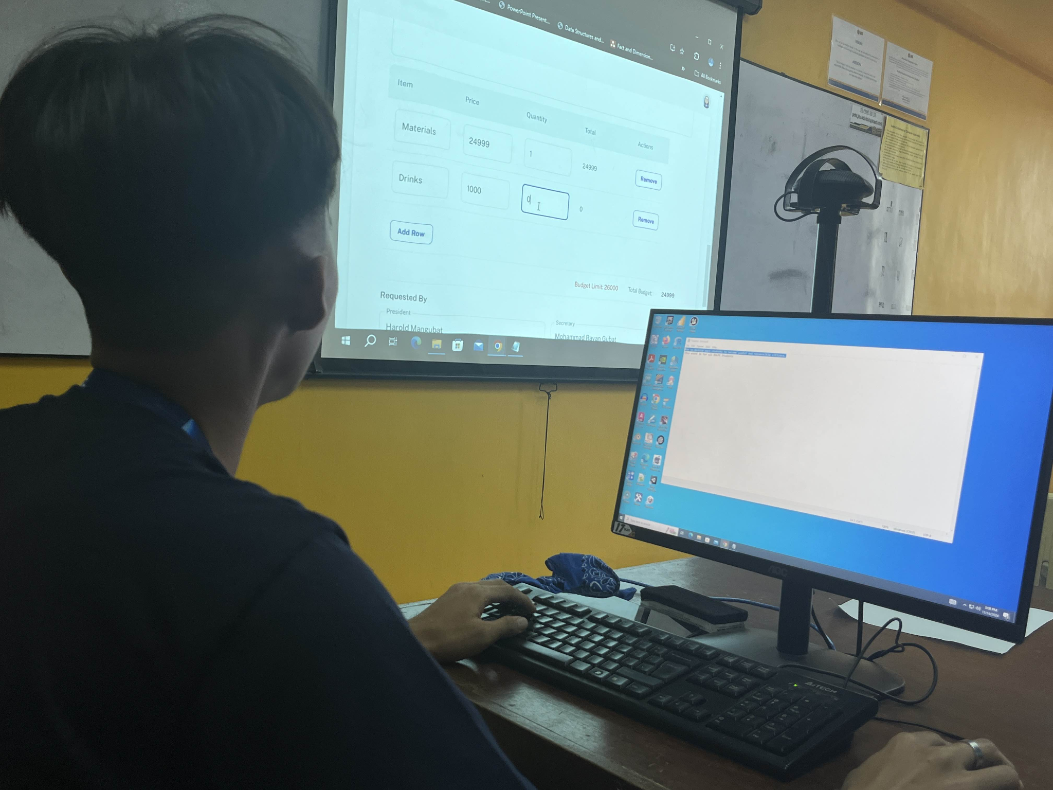

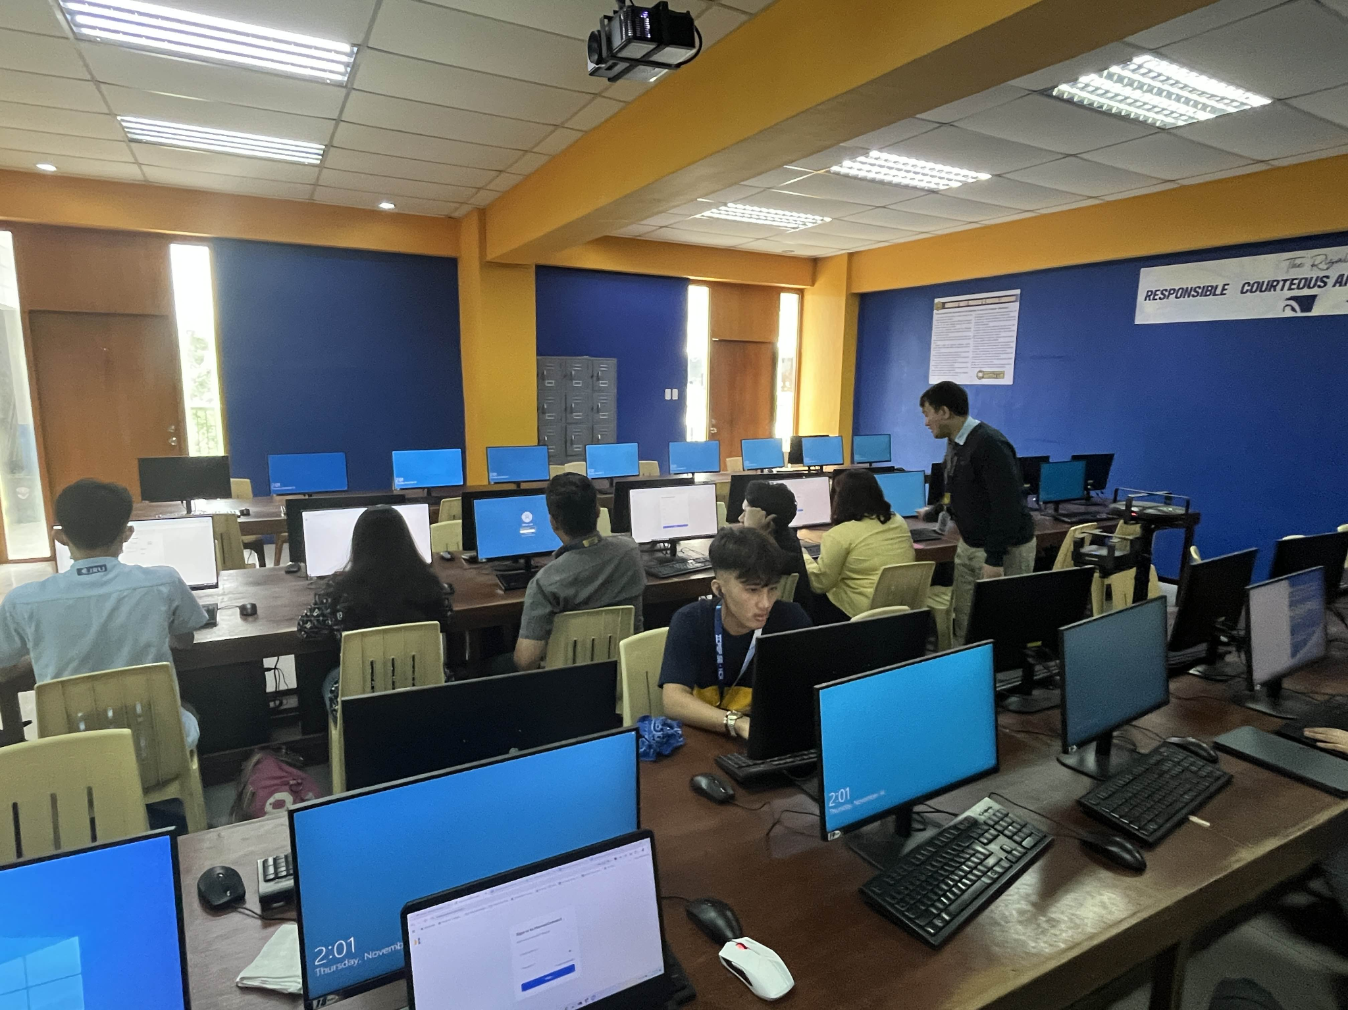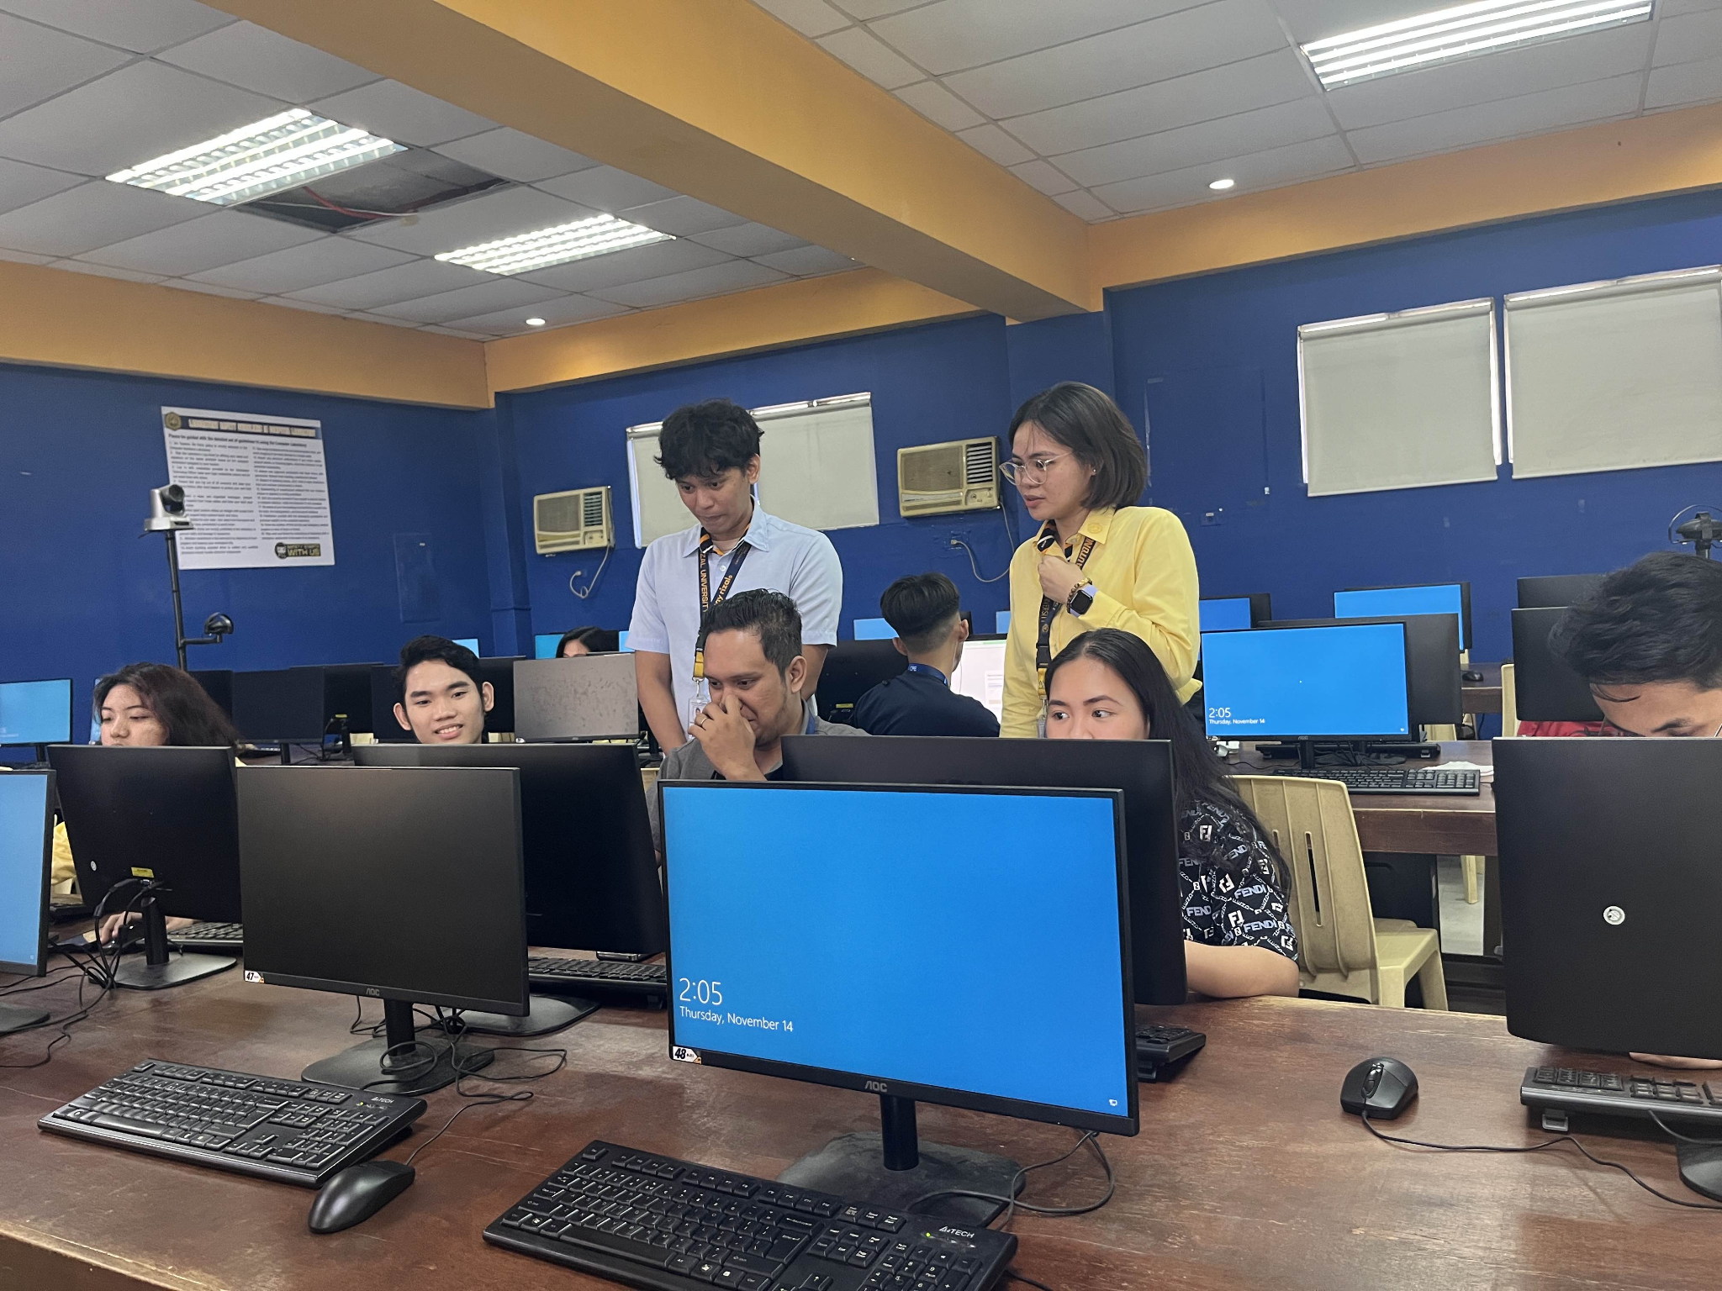

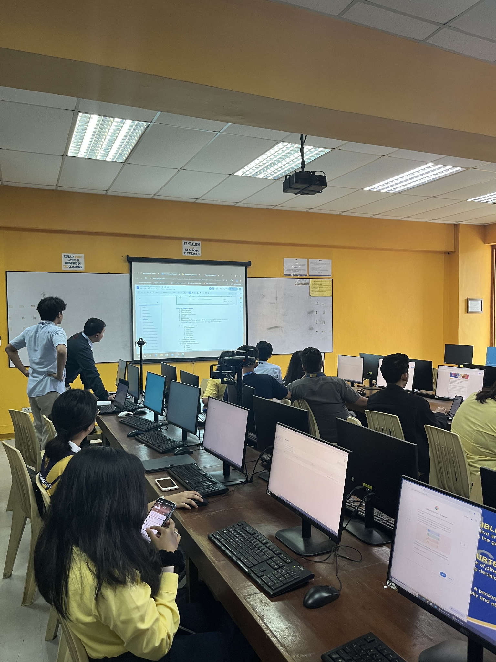

**Appendix E**

**ISO 25010 Software Evaluation**

| **Software Criteria based on**  **ISO 25010:2011** |
| --- |
| **I. Functional Suitability** |
| 1. Does the system covers the specified tasks and user objectives? |
| 2. Does the system deliver accurate results as expected, with the required level of precision? |
| 3. Does the system modules facilitate the accomplishment of specified tasks and objectives? |
| **II. Performance Efficiency** |
| 4. Does the system provides faster response and processing times when performing its functions? |
| 5. Does the system utilizes all the resources needed when performing its functions and meet requirements? |
| 6. Does the system handle the required number of users at the same time? |
| **III. Compatibility** |
| 7. Does the system perform its tasks efficiently alongside other systems or applications on the same device or network? |
| 8. Can the system easily exchange data with other applications or systems on the same hardware or software environment? |
| 9. Does the system components can exchange information with other products, or other systems components, and/or perform its required functions, while sharing the same hardware or software environment? |
| **IV. Usability** |
| 10. Does the system can be used by specified users to achieve specific goals with effectiveness, efficiency, and satisfaction? |
| 11. The user interface of the system enables pleasing and satisfying interaction for the user. |
| 12.The system has data elements which makes it easy to manage and control. |
| **V. Reliability** |
| 13. The system components meet the needs for reliability under normal operation. |
| 14. The system components are operational and accessible when required for use. |
| 15. The system components perform appropriate functions under specified conditions for a specific period of time. |
| **VI. Security** |
| 16. The system ensures that data are accessible only to those authorized to have access. |
| 17. The system prevents unauthorized access to, or modification of, computer programs or data. |
| 18. The system protects information and data so that users have the degree of data access appropriate to their types and levels of authorization. |
| **VII. Maintainability** |
| 19. Can the system be updated or modified without introducing new issues or affecting its current quality? |
| 20. Are there clear testing standards in place to verify that the system meets requirements, and can testing confirm this? |
| 21. The system can be effective and efficient with which test criteria can be established and tests can be performed to determine whether those criteria have been met. |
| **VIII. Portability** |
| 22. Can the system be successfully installed and function well in different environments? |
| 23. The system can be accessed in an online environment. |
| 24. Is the system adaptable to new hardware or software, like an updated operating system? |

**Appendix E.1**

**ISO 25010 Software Evaluation using a Likert Scale [28]**

| **Strongly Disagree** | **Disagree** | **Agree** | **Strongly Agree** |
| --- | --- | --- | --- |
| 1 | 2 | 3 | 4 |

**Use of a Scale for Results**

| **Rating** | **Scale** | **Verbal Interpretation** |
| --- | --- | --- |
| 4 | 3.60 - 4.00 | Strongly Agree |
| 3 | 3.0 - 3.5 | Agree |
| 2 | 2.0-2.9 | Disagree |
| 1 | 1 - 1.9 | Strongly Disaree |

**Appendix F**

**Grammarian Certification**

The undersigned hereby certifies that the final paper has been carefully read and reviewed every page of the graduate thesis entitled **HeroesConnect: A Unified Web Application for Student Organizations at Jose Rizal University,** authored by Krissandro S. Alfaro, Ana Kristina O. Catacutan, Raniel Shean P. Santos ensured that the writing adheres to the established structural guidelines governing English language sentence, phrase, and word composition. The study was presented as partial of the fulfillment for the Degree of Bachelor of Science in Information Technology.

Certified by:

Ariel C. Bartolata, December 15, 2024

Grammarian

Master of Arts in Language Education

Doctor of Education in Educational Management

**Appendix G**

**Jose Rizal University**

College of Computer Studies and Engineering

Department of Information Technology

**CERTIFICATE OF TURNOVER & ACCEPTANCE**

This is to certify that the HeroesConnect has been officially turned over to the client, Student Development Office, by 404 on December 18, 2024, at Jose Rizal University.

As part of the turnover process:

1. The system has been fully delivered to the client in its complete and operational form.
2. A detailed demonstration of the system's features, functionalities, and usage was conducted for the client, ensuring clarity and understanding of its operations.
3. The client has acknowledged the receipt of the system and expressed satisfaction with its presentation and functionalities.

For the Client:  
Name: Jasper Dosano  
Signature: _____________________  
Position: Coordinator, Student Development Office

For the Developer/Team:  
Name: Raniel Shean Santos  
Signature: _____________________  
Position: Developer

**Acknowledgment**

We would like to express our heartfelt gratitude for the unwavering support and cooperation we received from numerous individuals throughout this journey.

First and foremost, we extend our deepest gratitude to our Technical Adviser, Sir Emerson Flores, for providing guidance from the very beginning of this Capstone project. His encouragement to strive for excellence and his constructive feedback helped us avoid pitfalls during our defense. We are truly thankful for his time and expertise, especially given his demanding schedule.

We also express our sincere appreciation to our Student Adviser during Capstone 1, Sir Don Erick Bonus. His support and guidance during the initial stages of our Capstone were invaluable. We are particularly grateful for his consistent updates and feedback, which kept us on track and ensured meaningful progress.

To our Student Adviser during Capstone 2, Sir Ronnel Bilog, we extend our heartfelt thanks for his relentless encouragement to push for excellence. His assistance in ensuring we met our deliverables on time greatly contributed to the successful defense of our paper. We truly value his dedication and continuous support.

We also wish to acknowledge the Student Development Office, particularly Sir Jasper Dosano, the Student Coordinator. His cooperation, feedback, and provision of essential information were instrumental in making our work more manageable. We are deeply grateful for the time and effort he devoted despite his own commitments.

Finally, we extend our gratitude to all participants who generously gave their time to test our system. Their contributions and insights were crucial in refining our project.

To all these individuals, we owe our success and are profoundly grateful for the unwavering support and encouragement we have received.

**A. R. K.**

**Dedication**

This Capstone is dedicated to our families, whose unwavering support, encouragement, and understanding have been a constant source of strength and determination throughout this project.

To our mentors and advisers, thank you for your invaluable guidance in helping us navigate challenges and for believing in us even when we struggled to believe in ourselves. Your trust and advice have been crucial to our success.

To our team, we are deeply grateful for the support and motivation you offered whenever we faced difficult moments. Your collaboration and determination made this journey more manageable and fulfilling.

To our friends, thank you for your patience, concern, and encouragement, no matter the circumstances. Your kindness and belief in us have meant more than words can express.

Most importantly, this work is dedicated to God Almighty, who granted us the knowledge, strength, and opportunity to undertake and complete this project.

.

**A. R. K.**